# React Udemy Notes

(VS Shortcut: Format document is Shift alt f)

Originally websites are clunky with clicking around, not like a mobile app which is smooth and fun to use.

Javascript helped; it ran in the browser on the loaded page to manipulate the DOM (html structure) of the page. No need to wait for a new html page as a response

React is a JS library (client-side) and is about building reactive user interfaces for the web.

Why do we want React then if we can do just JS? (Demo)

There’s a lot more code to write with JS with just a simple function like opening a modal window

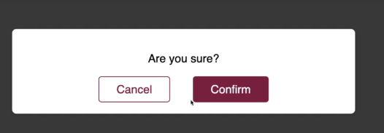

Every single step has to be described. (Imperative approach)

Multiple files, but the code is similar and split into components

React controls everything, and they use single page applications. In Netflix it appears to go to other windows, but in reality it is still the same page, we never use html to go to the next page.

**React alternatives**

-One of the most popular

-Lean and focused component-based UI library. May need 3rd party libraries to add certain pieces to it.

Angular

Uses typescript, ships more built-in features. Can be overkill for smaller projects. For large projects, you don’t need to rely on the community as much. Syntax looks different.

Vue.js

Mixture of react and angular. Bit less popular than react and angular

# ES6 JavaScript Refresher

Let and const – diff ways of creating variables.

Cost are constant values – assign once, never change

Let is the new var

## We used js.bin to test out some variable work

const multiply = (number) => {

return number * 2;

}

If all you do in your function is return, you can omit curly braces so you can write it as one line. Then you also omit the return keyword

const multiply = number => number * 2;

## Exports & Imports (Modules)

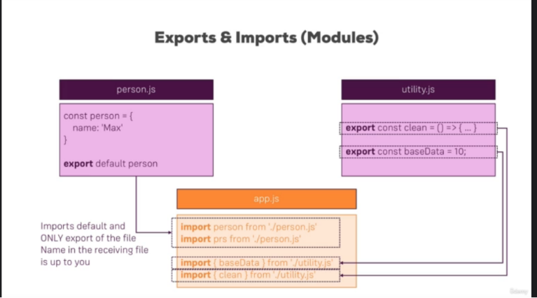

Person.js uses the default keyword. If we just import from that file, it will always import the one thing. So we can name it whatever we want (ex person or prs). Since in utility.js we didn’t specify the default, we give the exact names (clean and baseData) and the name goes between curly bases.

You can also do, {baseData, clean} since they’re from the same file. Also you can assign an alias with a named export like so

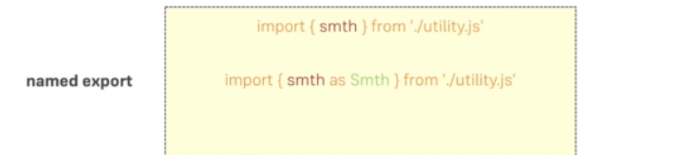

Or



Then you can do bundled.baseData and bundled.clean

## Classes

Class Person {

Name = ‘Max //property

Call = () =>{…} //method

}

Usage

Const myPerson = new Person()

myPerson.call()

console.log(myPerson.name)

## Inheritance

Class Person extends Master

When using a super class in the constructor you must call a special method super();

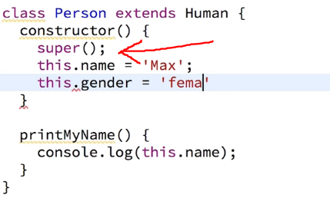

## Classes Properties and Methods

No longer need to declare default properties in the constructor, you can just declare the values outside

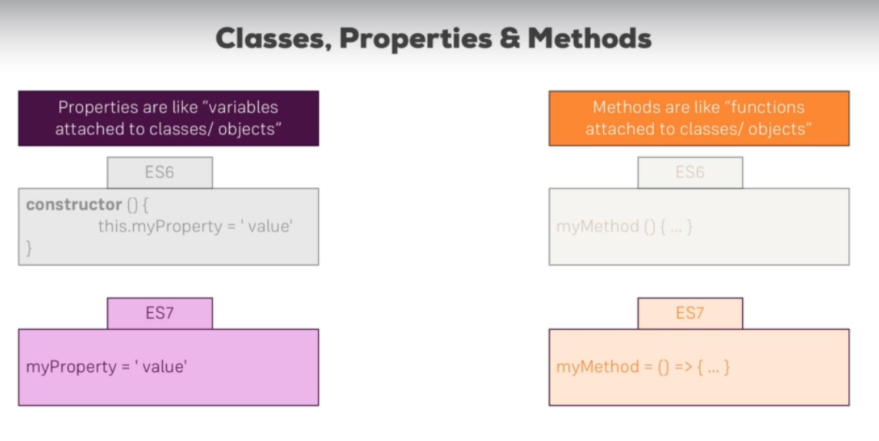

## Spread and Rest Operators

These are both the same, three dots. The name depends on where we use it

**Spread** – Split up array OR object properties

Ex.

const oldArray = [4,5]

const newArray = […oldArray, 1,2]

console.log(newArray) will print [4,5,1,2]

if you don’t use … it becomes [[4,5],1,2] as an array inside an array

Object property example

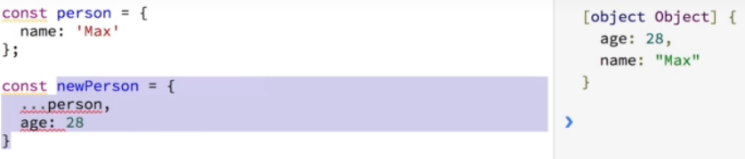

Here we are adding our old array into the new array and adding a 1 and a 2 element

**Rest –** Used to merge a list of function arguments into an array

Function sortArgs(…args){ //here …args means it could be any number of arguments, but we only need to type …and one argument

Return args.sort()

}

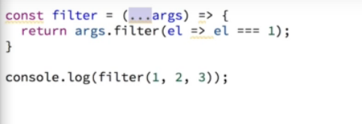

## Destructuring

Easily extract array elements or object properties and store them in variables. Different from rest and spread as rest and spread take **All** elements/properties

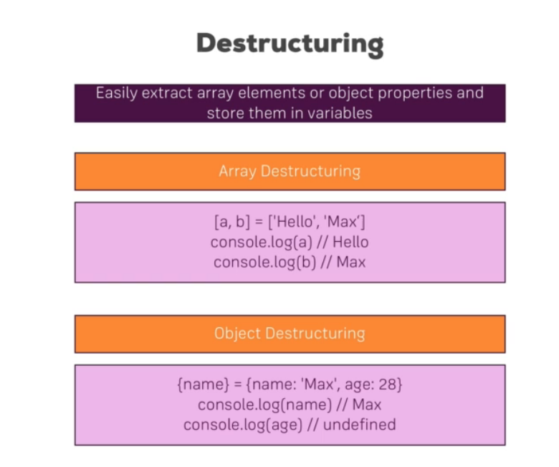

## Array Destructuring

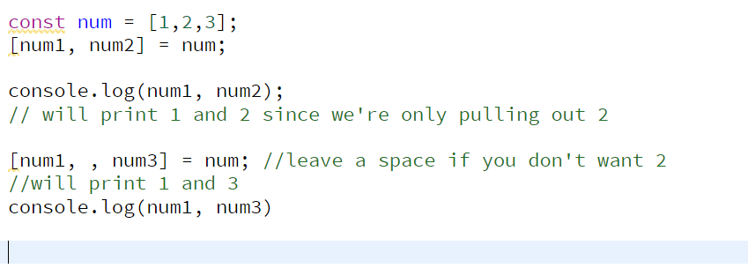

## Object Destructuring

JS.bin doesn’t support object destructuring but it looks like this

{name} = {name: ‘Max’, age:28}

Console.log(name) //max

Console.log(age) //undefined

Const number = 1;

Const num2 = number; //this is a real copy

## Reference and Primitive types

Primitive types(string, int, booleans etc) are exact copies while things like objects and arrays are reference types

For the example below you would expect the second person to be max but it has become Manu as secondPerson is just a reference so it changes when you change the item it is referencing

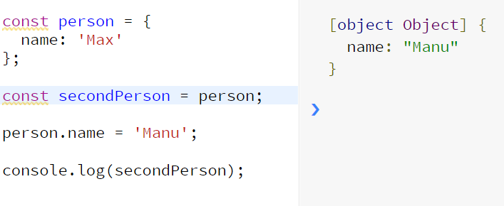

**If you copy an array or object and then change the first one, the copied version will also be changed**

Can lead to unexpected behaviors in React so be careful!

We can use the spread operator and that becomes an actual new copy

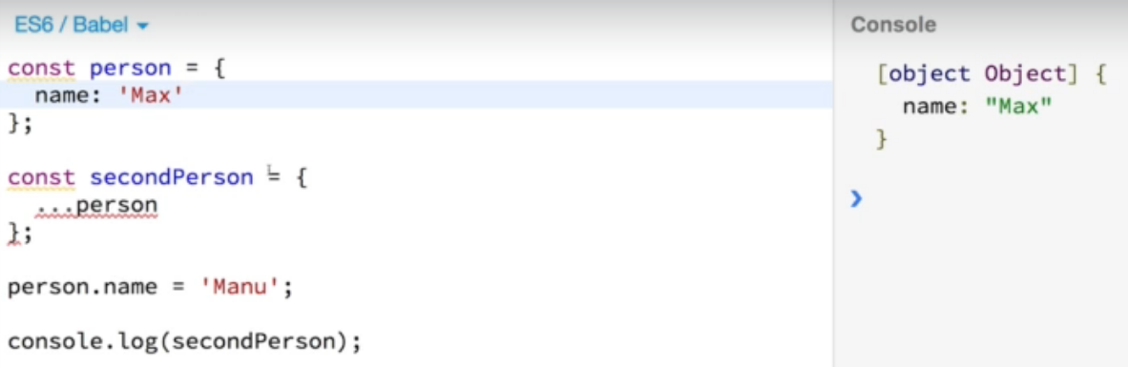

We’ll come back to this technique later

## Refreshing Array functions

**ArrayList.map() -** built in array method. Take fxn as input, and then executed on each element in the array.

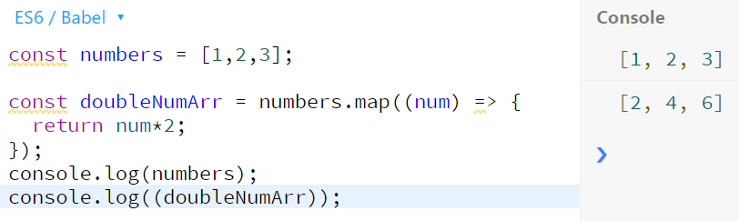

**Array functions include map(),find(), findIndex(), filter(), reduce(), concat(), slice(), splice()**

A lot of react concepts rely on working with arrays.

**map**-will create a new array populated with the results of the function you gave, after using it on every element in the calling array.

**Find –** returns the **value** of the first element in the given array that satisfies the provided testing fxn. If there is none, then undefined is returned

**findIndex** – returns the **index** of the first element in the array that satisfies the provided testing function. If there is none, it returns -1

**filter** – creates a new array with all elements that pass the test implemented by the provided function. If none pass it returns Array [] (an empty array?)

**reduce**-appears to execute a function supplied by the user on each element of the array before adding the previous element. The result is the sum of all the elements after the function is called on each one.

**concat**-returns a new array after merging two or more arrays

**slice**- returns a section of an array from start to end (start inclusive). A negative index indicates offset from the end of the sequence. For example -2 would be the last two elements

**splice**- changes the contents of an array by removing or replacing existing elements and/or adding new elements in place.

# What are Components?

React makes building complex, interactive and reactive user interfaces simpler. It’s a JS library that makes things easier.

**Components**-React is all about it

Why?

* Reusability (DRY)
* Separation of concerns – don’t do too many things in one and the same place (fxn)

## How is a component built?

Combine html and JS, and then some CSS into React

**React uses a declarative approach**

* Unlike with vanilla js, you define the desired target state(s) and let react figure out the actual JS DOM instructions

Run npm install to redownload and reinstall all dependencies

## Analyzing a standard React project

Src>index.js is where app will start. Behind the scenes there’s some other stuff that helps and make it suitable for browser.

Things such as ‘./index.css’; will not work in regular JS but they work with React.

root.render(<App />); also doesn’t work but it gets transformed until it gets sent to the browser

import ReactDOM from 'react-dom/client';

importing react Dom from 3rd party react dependencies

so with files, you will be exporting a file and importing into another file to use

the createRoot method creates the main hook, tells react where your react app UI, should be placed in the web page that is loaded. (in public>index.html)

Public>index.html the only html file being used by React application since it’s an SPA. It’s the entry point where the react interface is put

<div id=”root></div>

Is where the React UI should be rendered into

And then we tell react in root.render, we want to render (<App/>);

**What is that App thing?**

its our App.js file (a library or your own .js file doesn’t need the .js extension)

**Looking in our App.js**

Our simple file currently, we define App, return and export it. This is not normal valid JS code, but it’s actually JSX.

# JSX

A syntax extension to JS, it looks like a template language but has the full power of JS, it produces React “elements”

Any valid expression can be put inside curly braces in JSX.

# Building a first custom component

You build a component tree with react

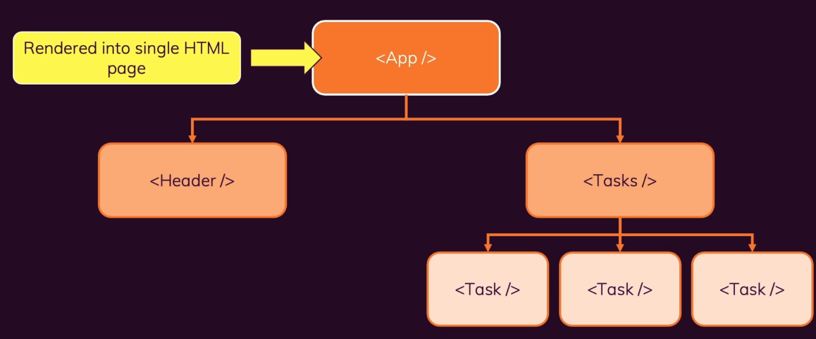

You can have very big SPAs where only the top component is rendered into the HTML page with the DOM instruction. All the others will be used as html elements inside of our html code

A component in React is just a JS function. It’s a special kind of fxn still. Once we write the fxn we export it, and then import it where we want it.

**Custom components must start with a capital letter so that React can detect that it’s a custom component.**

Return statements in JSX should only have one root. We can enclose this in brackets or just in a larger <div> wrapper

## Adding basic CSS

Modern convention says add .css file next to the specific file it is targeting

Don’t type class=’’ in divs, add className because class is a reserved word

## Outputting dynamic data with expressions in JSX

We can fake some dynamic data first by declaring constants and using those with {} to replace the strings. We call these dynamic placeholders and they can be the result of a variable, http request or a calculation etc.

## Passing data via props

How to make it reusable? Very easy, just call it over and over again via tags

<ExpenseItem></ExpenseItem>

<ExpenseItem></ExpenseItem>

<ExpenseItem></ExpenseItem>

* For the function we can call it via different parameters
* For react we can use different parameters and also props
* Components can’t just use data stored in other components

## Props (stand for properties)

Add an attribute and inside that item add the attributes that are passed through that item

We created an expenseItems array inside App.js and then we need to pass those via <ExpenseItem>

as attributes

Then we went into ExpenseItem.js and instead of passing in title, amount, date as parameters we get one. React ensures we get one parameter in every component that we use. And it will be an object that holds all the received attributes as properties. Hence the word props. You can name it whatever you want but usually it’s props

Prop is key value pairs

Through app.js and through attributes, you can show how you want React to display the ExpenseItem component

**You’ll use props all the time, super important concept, allows React to reuse components**

## Adding normal JS logic to components

Splitting month day year of the calendar

## 39.Splitting components

Keep components manageable and small

Our ExpenseItem.js is getting big and our date can be treated as a separated component. No hard rules.

We created an ExpenseDate component. Now we have multiple components nested inside each other.

In the App component we’re using the ExpenseItem component and within that, the ExpenseDate component  
App.js>pass to ExpenseItem child > ExpenseDate child

Sometimes all an element is doing is passing data through

## 40. The concept of “Composition” (“Children props”)

      In general, building a user state from smaller building blocks is called “Composition”

What about a component that acts as a shell around any other component? We currently just have very specific components.

Sometimes we just want to pass items through the opening and closing component

* Ex. Boxes and containers (Light grey and dark grey backgrounds with rounded corners) Here we have style and html structure duplication
* These are also normally called “Card” in web development where it’s a container with rounded corners and drop shadows
* We tried to replace div with our own custom <Card></Card> Element but it didn’t work
* We then imported within Card.js a {props.children} prop 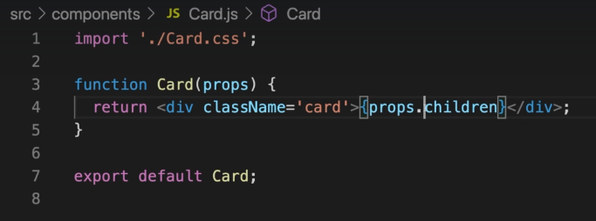
* .children is a reserved name. It is always there even when you don’t export it. It will always be within the opening and closing tags of your component. For example <Card><Card/>
* It was a bit broken as our custom <Card> was not using other class names
* Withing Card.js we added a constant called classes and made sure it took in as props the className as well.

Const classes = ‘card ‘+props.className; //making sure to add a space since html requires different class names to be separated by a space. So for className we are both using the card class and also the props.className class

## Why did we do that?

Extract some code duplication. Some JSX can have more complicated things such as modals and alerts. Then we will save lots of code duplication and make sure all have the same format for our UI

More examples to come 😊

**COMPOSITION IS VERY IMPORTANT!**

**Esp props.children**

On the website, you wont see custom components, you’ll just seen plain ol HTML elements, because at some point any component if you drill in long enough will just be html.

In the end our current project is still static. Data still set in stone.

## 42.A closer look at JSX

In older React projects, you needed to import React from ‘react’; in all files where you use JSX. There are a lot of React projects out there that do that.

In JSX, if you remove all the fancy syntactic sugar, it’s still using React methods.

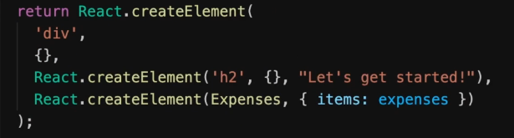

Nowadays you can just use JSX and the product is able to make that transformation

That is why you need a wrapper to return your html tags

## 43 Organizing component files

Once we got more and more components, we should have subfolders.

So far we have UI and feature specific components. So we put the UI stuff into UI and the rest in Expenses right now

## 44 Alternative function syntax

Instead of function, you can replace with const App = () => {}

Const is what some people prefer

**Moving onto User Interaction and State**

Handling user events, how we ensure what’s visible on the screen changes “State” concept and transition from A to B

## 47. Listening to Events and working with Event Handlers

We have full access to native DOM events like button clicks and whatnot

For each of these, theres a prop equivalent in React. Instead of the usual html way, in react we go to the JSX element and add a special prop. And then the handler prop will call a function.

**We can call the fxn within like so**



(this can be see on the web site under Dev tools -> Console

This doesn’t have to be an arrow fxn either, it can be function() {}

But usually you don’t want to put too much logic in to your JSX code

**Or make a function and add the name in the html element, in this case the button**

It doesn’t matter if it’s a function or a const.

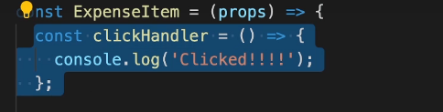

Note that you don’t call the function like clickHandler(), you just point at it



Why not call the function? It would be too early as it would execute immediately.

If an element supports an event, then you can use React with it. Just make sure the even starts with a capital character. For example like onClick the click start with capital C

Note: Optional Naming conventions, instructor called his function clickHandler which is a convention. If they are triggered by an event, that you can follow it with Handler which means it is attached to an event listener. That way we know that devs don’t call that fxn but that it’s handled by React and that it’s attached to an event listener

## 48. How component Functions are extended

We tried to do a function like this

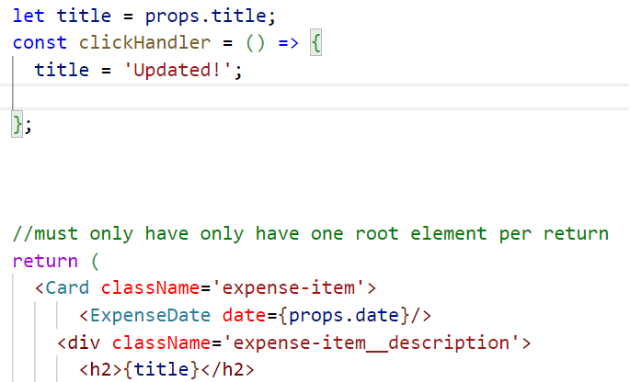

But upon button click the title did not change. However using a console.log still showed a title change so the function was actually working. But no updates to the website UI.

**Why?**

We never call our component functions, instead they are like html elements in JSX code. React is aware of our component functions, it will call these components, and then these component functions call JSX code which is also evaluated up until there is no more JSX component code evaluated.

Then evaluates all the code and makes it into DOM

React never repeats it. It only goes through it once.

But what if a button is clicked? We need a way of telling React that something changed and that the component should be re-evaluated

**Introducing STATE**

## 49. Working with State

State not React specific concept

**1.Import a named import called useState**



**2.We call it inside a react component function. It can’t be called outside, or in nested fxn.**

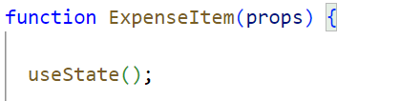

**3.** Set an initial state

useState(props.title);

useState is an array that always returns exactly 2 elements

so then we can use **array destructuring**

const [title, setTitle] = useState(props.title);

//this would be the title is the current state value, and the setTitle is the one that updates the value.

This setTitle is a special function and the component actually gets updated again, which is why we see the title change

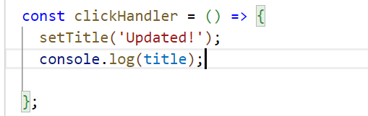

The console.log still shows the old title as well because the component gets updated at a later time. So the function runs first

## 50. A closer look at useState hook

State key concept in react. Why a const? useState registers some value as a state for the component. Every ExpenseItem gets its own state which is separate from the other 2. Every time an ExpenseItem is called, it has its own state. (For ex. Clicking button changes only one state. So it’s a per component instance )

Why are we using const when we’re assigning a new value?

useState is us getting React to handle titles for us, we’re no longer reassigning it.

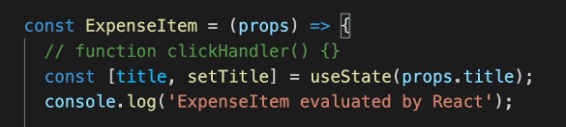

Under the hood, Props.title is only evaluated when it is initiated for the first time. It won’t use that later on

## 51. State can be updated in many ways!

Later on we can use http requests. You can also use state in lots of different ways, like a timeout as well

## 52. Adding form inputs

Added a new ExpenseForm.js and then a NewExpense.js

## 53. Listening to User Input

We want to get what user input and store that somewhere. So we need listeners first.

We added an onChange to our form input title. And actually we always get an event from React when we do that, which we can look at by capturing like so

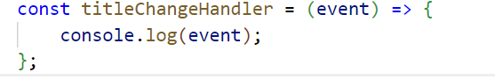

The input element within event has a long list and it also has a value property.

## 54.Working with multiple states

When the overall form is submitted, we want to make sure all the values have been saved so that we can get them.

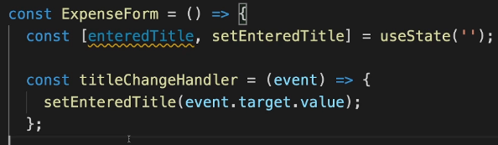

Here the initial useState is empty but we can still grab those two values. Then we use our const titleChangeHandler to keep that value and state. We’ll need that state for update and rendering later anyways

**How can we manage more than one state?**

**You can call it more than once and they will all be separate**

By the way all values captured will be in string even if they are numbers or dates

**Using multiple states to capture these values is ok and normal!**

However…we can also capture it in one state

## 55.Using One State Instead ( And What’s Better)

In the last part we used multiple handlers and multiple state slices, which is ok. However we can also have one state. It’s just based on your preference.

Easy, just call useState() but this time put in an object like so useState({});

   const [userInput, setUserInput] = useState({

    enteredTitle: '',

    enteredAmount: '',

    enteredDate: ''

   });

But keep in mind now that you need the values for each one.

When you’re assigning the changed value, make sure you add the values for the unchanged fields too otherwise they will be lost. Here we use the JS spread function

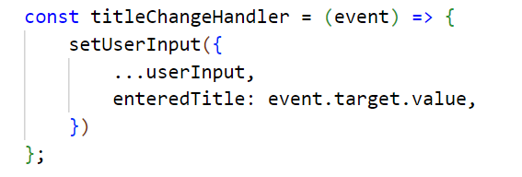

**This code isn’t perfect so far so now…**

## 56.Updating State that depends on the previous State

Previous code technically could work, but not great to update like that. Since we’re depending on previous state snapshot

**Whenever you update state and you depend on previous state, you shouldn’t do it like this**



**but instead, use an alternative form of state updating fxn**

here we pass in an arrow fxn that has the previous state and then return

setUserInput((prevState)=> {

return {…prevState, enteredTitle: event.target.value};

});

**Why would we do it this way?**

Because React schedules State updates so if you’re using the other way you might be depending on an outdate State snapshot. If you use the function in function method, React will make sure you get the latest snapshot. So this way is the safer way

**If your state update needs the previous state update, use this fxn form!!!**

We decided to return to the multi state approach which is more common to see

## 57. Handling form submission

Now we make sure when the form is submitted, we gather all the state slices and then for the moment it will be logged to the console but we can use it later.

We could add an onClick fxn on a button, but if a button is pressed in a form there’s a built in function that can submit the whole form. So on the <form> we call <form onSubmit={submitHandler}>



Unfortunately clicking the button causes the page to reload. We want to manually handle it via JS.

Thankfully we can prevent it (this is JS behavior)

## 58. Adding two-way binding

Another key concept, very important! So now you know how to gather information but also change it upon form submission

We want to clear the input fields after submission so we added the value as value={enteredTitle}

Or whatever the name was in the <input>

## 59. Child-to-Parent Component Communication (Bottom-up)

We actually don’t need this in the expenseForm element, we need it within NewExpense.js and ultimately in App.js

We can do parent to child via props

**But how to do it the other way?**

We can think of an input element as a component as well. It’s not one of ours but it’s prebuilt. We also set some props on that component.

ExpenseForm => NewExpense => App component

**We can’t skip components in between.** Props only work parent-child, cannot skip intermediates

Within new expense, we wrote an event to capture when the form gets saved in ExpenseForm. You can name that whatever you want since its your custom component

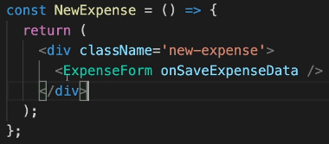

We write the function for that very onSaveExpenseData event in that component, and then we get that captured data and make that into a new object using spread(…)

Then inside ExpenseForm we will accept props and call props.onSaveExpenseData()

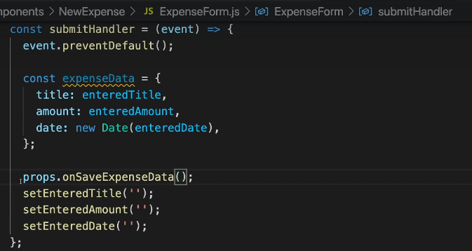

which is actually calling the function saveExpenseDataHandler

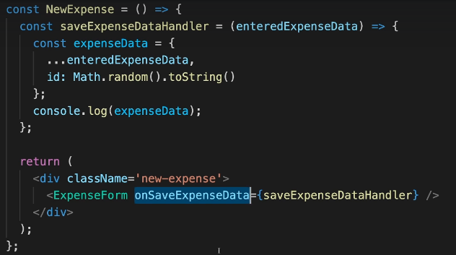

**This is a super expensive pattern to know in React!!!**

Basic How It works

1.Write a fxn in the component that needs the info

Ex. **In App.js**

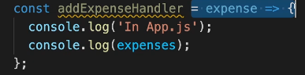

2. reference that function in the component tag you’re getting the info from

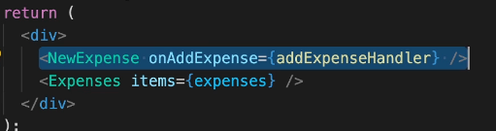

3. inside THAT component **NewExpense.JS**, accept (props) in the main function

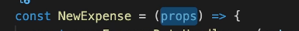

4. write a function that uses props.

Here it would be that function that was created in **App.JS,** onAddExpense. So it needs to be the same name



5. Then In **App.JS** the addExpenseHandler will be able to take the data from the child component and do something. So here we just call it expense and we can use that data now in App.js



## 60. Lifting the state up

Moving data from child to parent by using props, closely related to a key concept called “lifting state up”

Pretty common where you generate data but you don’t want it in that component, you want it somewhere else. But we cannot go between components, we need to go from parent to child and child to parent

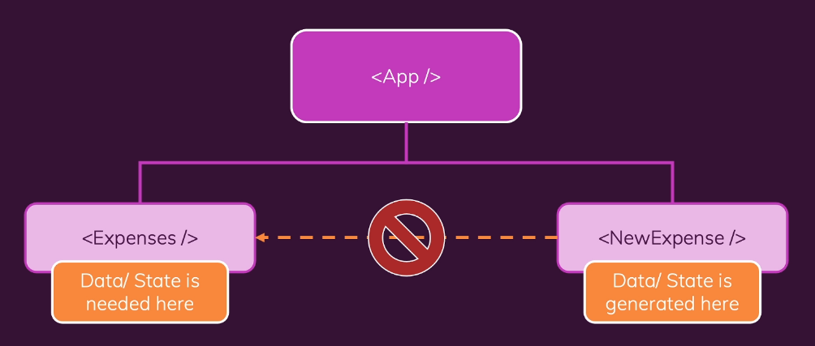

So we need a component that has direct access to both components. In this case it’s <App/>

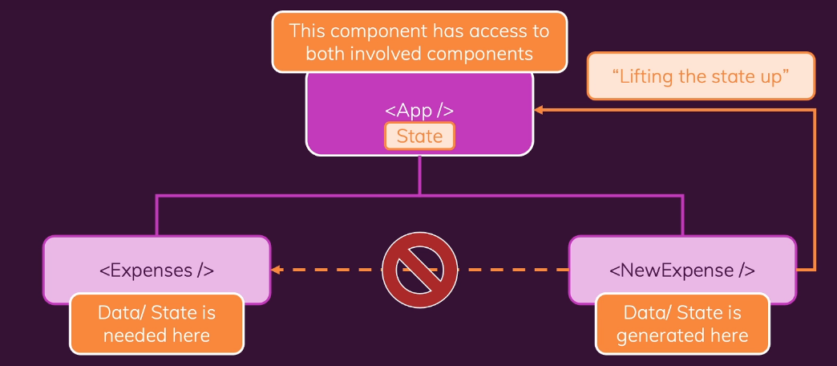

Once it’s in App.js, we do want to pass that data down via props

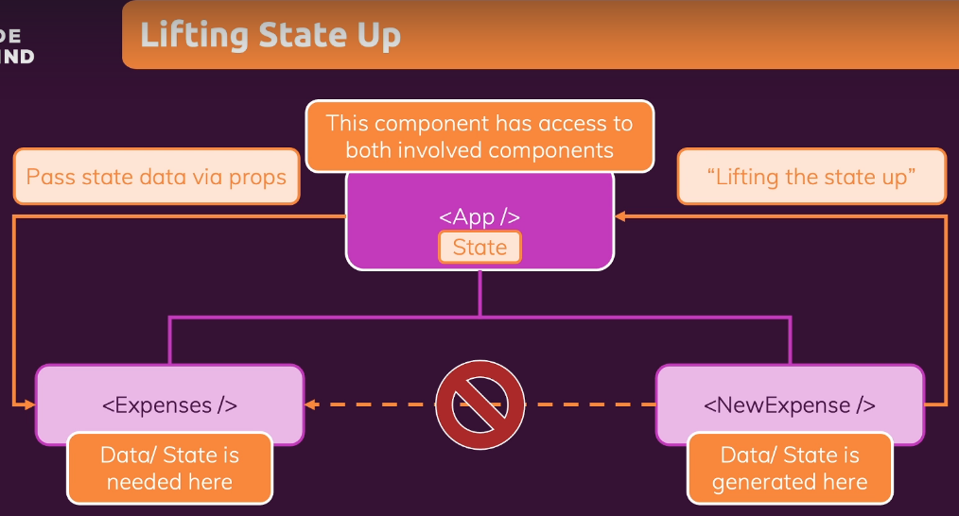

**Lifting state up** will refer to a child component passing data to a parent to either use it there or to pass it down to another component

**You want to lift it up just enough to have the part that generates data and needs the data**

Within my own state data setup, I discovered that the fxn that is setting up for example, setFilteredYear will not have the filteredYear yet if it’s left blank as default.

So this will console.log undefined for currentYear since it’s left blank(the setCurrentYear will not have populated the currentYear yet, but it’s ok since we can just use event.target.value)

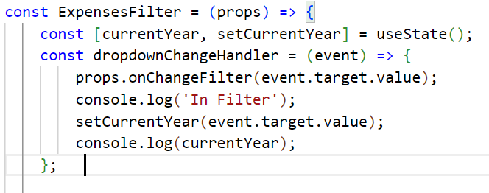

**As a bonus, you can set the default for the selection by** putting a function into the component before it.

First you set the default useState. Here we want to set the filter to 2020. So put that in there first

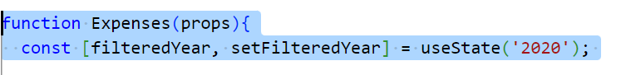

And then in the component call, naming it whatever you want and then the value like so 

So here selected can be named anything. You could even called it OogaBooga

Then within ExpensesFilter, you can call it via props.selected or props.OogaBooga

Page will start off loaded like so



## 61. Controlled vs Uncontrolled Components & Stateless vs Stateful Components

The two way binding previous lecture is called Controlled Component. We controlled our custom component. It means that a value used in the component is passed onto a parent(through props) and is received through parent.

**The values are not handled in the component itself, but in the parent component**. The parent “controls” the child component

**Stateless vs Stateful components**

In basically all React at, you’ll have a couple that manages state. Then you have others that don’t manage any state (also called presentational or dumb). You’ll usually have more stateless than stateful.

# SECTION 5: Rendering Lists & Conditional Content

## 65. Using Stateful Lists

Arrays of data via lists and rendering content under certain conditions

In our expenses.js file we are hard coding the ExpenseItems so now we want to change that

This is actually pretty easy as we can use props which has our items and then use vanilla JS’s .map function.

(In App.js we attached our expenses list to the Expenses.js via a name called items so we call that in Expenses.js)

We pulled out the expenses dummy data and labelled it as such(DUMMY_EXPENSES).

Then we initialized our useState with DUMMY_EXPENSES and set our two functions

We then wanted to add the new expense but include the dummy ones. We **could** use the spread operator but that’s not the correct way, the correct way is to pass it in as an arrow function into setExpenses. prevExpenses we can name whatever we want

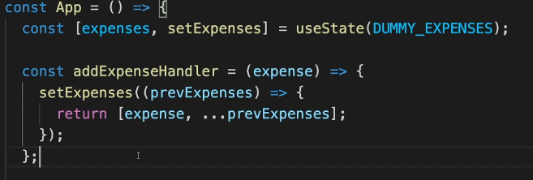

## 66. Understanding “Keys”

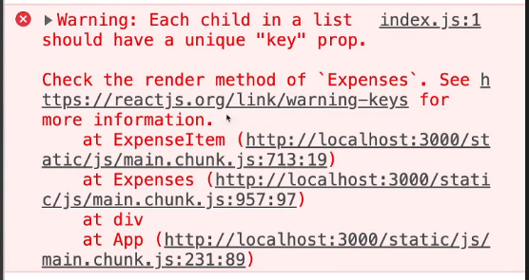

We got this warning that each child in a list should have a unique “key” prop. It has to do with React’s special concept. It wants to do that without performance loss or bugs.

While looking in dev tools on the app. It adds a new div at the end and then updates all of them to match the list. All items are visited and updated. Takes a long time.

State changes could be lost too.

**Why does React behave like this?** No other way, just checks length, number of items rendered. Individual items all look the same so it doesn’t know where the new item should be added.

**We went into Expenses.js** and added a special prop **key**

You can use this for standard or custom components

You then set it to expense.id. You could also set it to index but that’s not recommended since that is independent of the item’s contents.

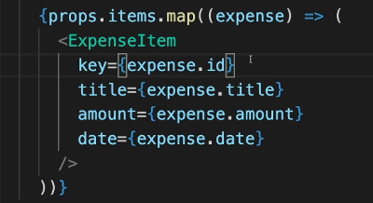

**I was unable to complete the challenge as the filter array confused me**

However the solution is as follows:

Within Expenses.js, We wrote a constant called filteredExpenses and used our props.items that we were already getting, we called .filter on that, which uses a function to return a new array (therefore not touching the original one)

Our function for that was to return items where expense.date.getFullYear).toString() === filteredYear

And then within our <Card>, instead of props.items we changed it to filteredExpenses.map and then everything was the same

## 67. Outputting Conditional Feedback

Our year filter is working, but we can select values where we have no data, so we might want to show a message when we have no content

Within expenses.js we used a turnary expression to show when filteredExpenses.length === 0 to show <p> No Expenses found. </p>

**However, long turnary expressions can be hard to read.**

We used a very common technique from JS to make it simpler to read. If JS reads the first part as true, it will display the part after &&. It’s a very common thing in React projects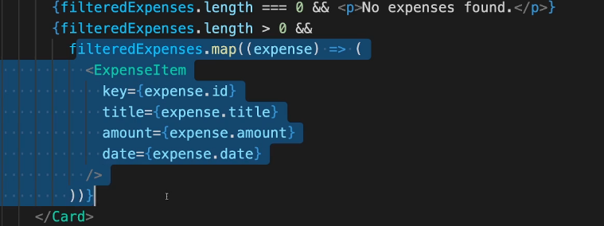

**If this is still too much code**

We can store jsx content in variables



And put an if statement outside of the return

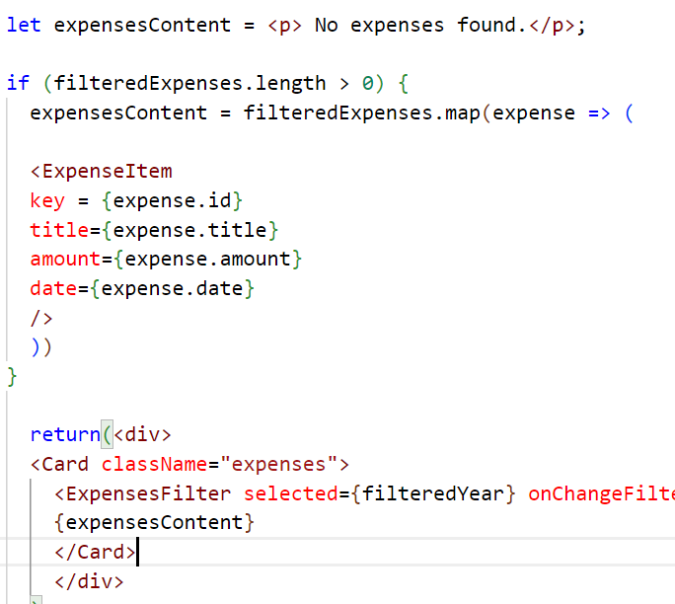

Leaving us with a very lean return that just has the dynamic expression {expensesContent}

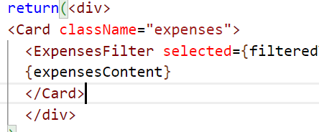

## 68.Adding Conditional Return Statements

Added an extra component called ExpenseList to make Expenses even leaner. Created 2 return statements in there.

## Assignment 4

We added a new add expense button and a useState constant to track when NewExpense was in editing mode or not (clicking the Add expense button puts it into editing mode)

We also wanted to add a cancel button, so in NewExpense in the ExpenseForm component, we added a function and called it onCancel and passed it the stopEditingHandler

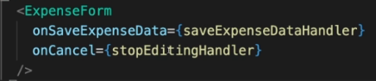

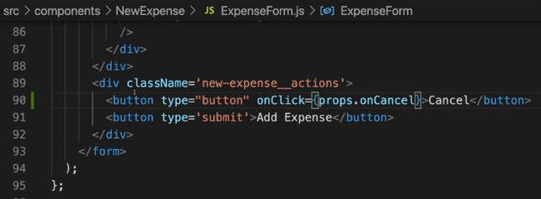

Within ExpenseForm we had an onclick which we passed the props.onCancel. This is different than previously as this onClick actually calls the other function immediately. (Previous uses of handlers and passing in functions was related to events where we added data and had to do other things, and inside those functions we called the method later on after the data was stored/calculated.

Also in the saveExpenseDataHandler, once all data is submitted we also want to setIsEditing(false);

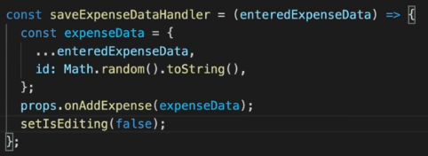

## 69. Demo App: Adding a Chart

We wanted to separate chart and chart bars so we created ChartBar and Chart.js and the respective styling sheets

Each bar represents a month, so we wanted to use props to help guide how many <ChartBar/> elements there will be. We assigned a key to it so React could track it better as well.

## 70. Adding Dynamic Styles

We are filling in chart bars so in ChartBar.js we should be calculating by how much each specific instance of chart bar should be filled

We also want to set a style dynamically. Style wants a JS object as a value, while React also wants curly braces dynamically. That’s why we end up having double curly braces



Example



## 71. Wrap up and next steps

Currently all .css files are global so you can call .chart-bar etc anywhere and it’ll work. But in the future we might want to scope it. More on that next section

# Section 6: Styling React Components

Web apps with React is not just about using components together and making the logic works correctly. That’s the most important part but you also want to style the apps and make them look good.

There’s different techniques where components are not affected by other styles.

**Conditional & Dynamic styles** - also scoping styles to components (they only affect the component)

We initialized a new starting project and played around with it. It contains only components and stuff that we already know.

Currently user can submit an empty goal and it will still display a blank purple line. We don’t want that. In CourseInput.js we adjust formSubmitHandler before we trigger props.onAddGoal

Currently this never reset. Also we used inline styles such as 

Inline styles take the highest priority and will overwrite our other ones

## 76. Setting CSS classes dynamically

What could be the alternative to inline styles?

Adding new css class dynamically only if the value added is invalid ( It will only sometimes be added)

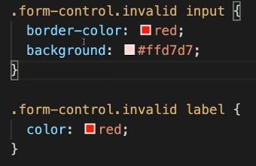

We added these two invalid CSS class styles into CourseInput.css

Instead of writing inline css, we use {form-control}

And then even more, we used backticks like so 

Which is a default js feature called a template literal. And whatever you type between will be a regular string. You can also inject content into the string

## 77. Introducing styled components

We want the styles being scoped to component only, so for example if we had .form-control anywhere else, it would take on the .form-control style within CourseInput.css for example. With many developers working on the same project, there’s a chance that the same name could be repeated twice.

**Approach 1. Use a package online called Style components**

**Approach 2.** To be shown later in 80. Using CSS Modules

Style is an object that we’re importing from styled-components



We used an unusual syntax that’s a default JS feature called attacked template, literal

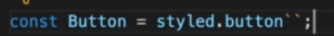

Instead of parentheses, you add these backticks. What you pass in the backticks will be passed in a special way

You can also add a multi line in the backticks.

We copied all the button.css styles and added them into the button.js between the backticks

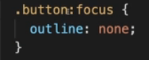 for pseudo selectors like this, you would use the ampersand symbol

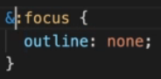

What this package does is look at our button style and generates a class name where it guarantees that every class name is unique. Then add these classes as global css

## 78. Style components and Dynamic props

You can use it as a div too, and you might want to use the style elsewhere as well

We replaced our div and declared a new const

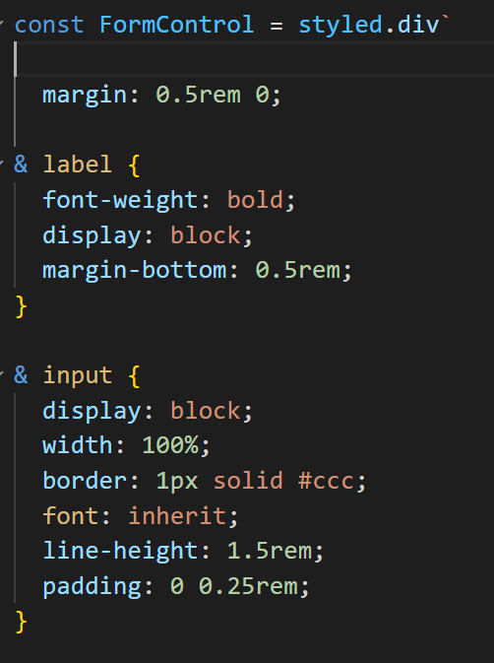

But then our props no longer worked so we needed to figure out how to add that back in

Solution 1



Solution 2



Then we also dynamically changed the results by passing in props since we can use ${} within our styled component

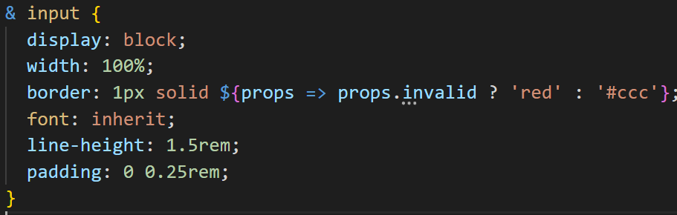

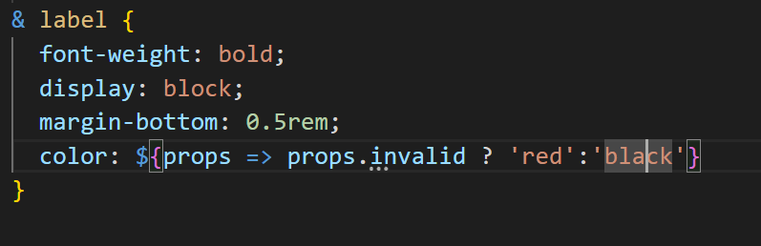

Last use case

## 79.Styled Components and Media Queries

Media queries are when the styles need to match a certain browser like maybe a cell phone device etc.

We looked at our website in a phone and it looked ok. But we might want the “Add Goal” to span the whole thing when on a device but only a certain amt otherwise

So here with large screens the button only takes up as much space as it should

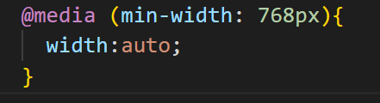

Less than that and it’s set to 100% to max size

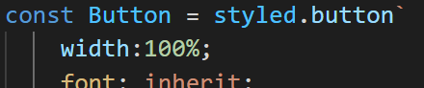

## 80. Using CSS modules

Can only be used in projects that are configured to support it because it needs a code transformation that needs to be done before the code is run in the browser. Create react always comes configured with this.

Rename your css file to include module, so example Button.module.css

And then import styles from ‘./Button.module.css’;

And then in the JSX, you can call the classname as an object instead and every style in the css file is now a property so you can go



The class names are later dynamically generated

## 81.Dynamic Styles with CSS modules



Invalid property name in styles as form-control, so we use square brackets and wrap with single quotes.

Then we injected a string using backticks and added an additional class which was the !isValid && styles.invalid, referring to the converted version of our own class

Then we add media control like this, adding back in the selector .button{}

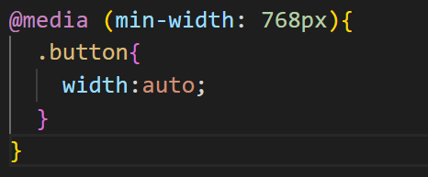

# Section 7: Debugging React Apps

Errors will always happen

**Finding and fixing Errors**

We shall

-Understand Error messages

-Debugging & Analyzing React Apps

-Using the React DevTools

## 84. Understanding React Error Messages

Here we learned to look at the error message, the code snippet and then fixed the error in our actual code

## 85. Analyzing Code flow and warnings

Trying to solve an error where there’s no error messages, for example we’re deleting a goal but it’s not deleting that one, rather it’s deleting a different one.

Option 1: We go to the deletion function in the code, walk through all the functions connected and discovered that the id was hard coded (all called `goal1`.)

Option 2: We could also look in developer tools and there might be an error or warning message that gives us an answer there.

Here we get that warning that says two children have the same key (`goal1`)

Option 3: Use debugger built into the browser using breakpoints

## 86. Using Breakpoints

Within the browser, go to developer tools and then source. Then you can look at the code in its raw form.

From users go to source and then you’ll find your app.js  
If not there you can can also check out the webpack folder where there might also be a src

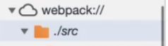

From there you can click on the line that executes the problematic code. Now you run the action on the browser that executes that code.

Use the symbols to step over or step into the fxns

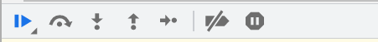

Afterwards press the first button (play) to resume functions

## 87. Using the React DevTools

We added the *React Developer Tools* extension to Chrome

Then we had two new tabs after console, *Components and Profiler*

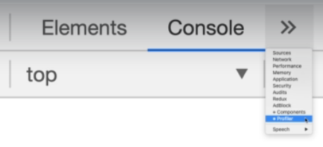

Click on **components** and you will see a component tree. You’ll only see React elements, unlike the elements tab in the browser which show a DOM. You can click on the components to get more info about them

Within App and CourseInput you’ll see hooks. Remember useState is part of a series of hooksof hooks.

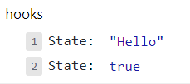

**You can actually change the state, and it will be reflected in the end result.**

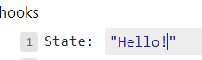

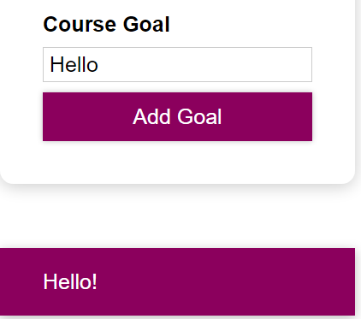

It’s not updated in the input field as we did not tie it to the value but it shows up in the goals section as Hello! As it was changed in the state, and it will have an effect on the UI

# Time to Practice: A complete React project

We started off by looking at the completed project and determining what we wanted to add to the project. We started off with an AddUser.js component with a form component and a button. We added that as its own element to the App.js (where all things start). App.js only contains that element so far

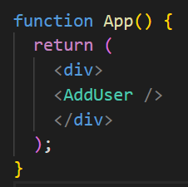

Within add User we took in props, then for the onSubmit we added addUserHandler

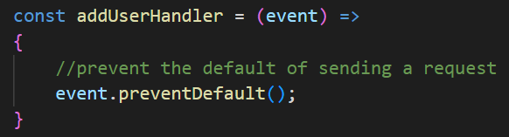

We prevent the default as submitting the form would try and send a request and we want to prevent that, we want to do our own thing

Then we wanted to add more styles and a custom card for rounded edges so we renamed our .css file to

AddUser.module.css which is a modules way of doing things, then we imported it this special way.

 instead of the usual .css way which is no naming

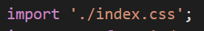

We used the Card.js to return the element with our own style and we used classes and string literal since our custom element wouldn’t have things like className and stuff. So we imported props.className

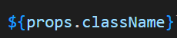 (className could be named whatever we like, but it’s nice to have className for consistency)

**Card.js**

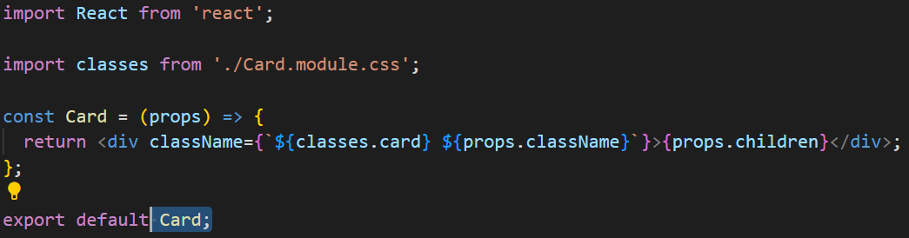

We also created a custom button component with our own styles

Button.js

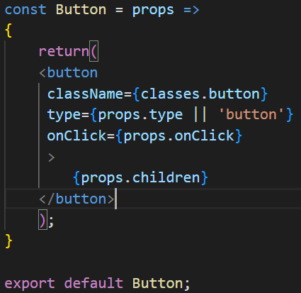

We used classes.button which references the inside of our Button.module.css file which contains a .button class then we wanted to make sure the type would be either what we specified in our props or a button. And the onClick we wanted to use our own on click call. For the label we wanted it to be props.children

## Getting the data

We added two constants and implemented useState



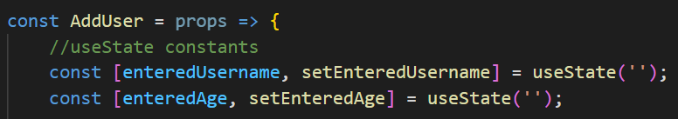

We added these handlers to capture the values

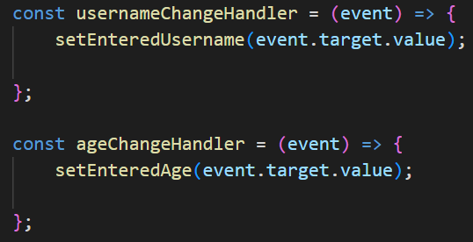

They are in the onChange html elements here



We then wanted to reset the fields back to blank after the data is inserted, which is easily done using this at the end of the add User fxn

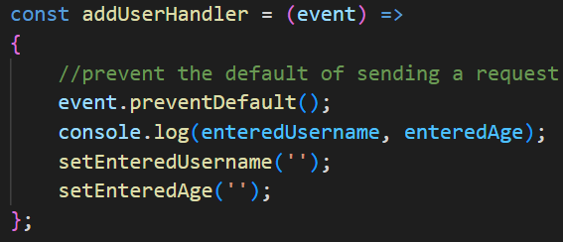

The inputs then have to be updated with value = {enteredValue} to show a change. For example this one shows enteredUsername



## Error Handling

We then added error handling within the addUserHandler. Note the comments in green. Trim will remove any excess whitespace.

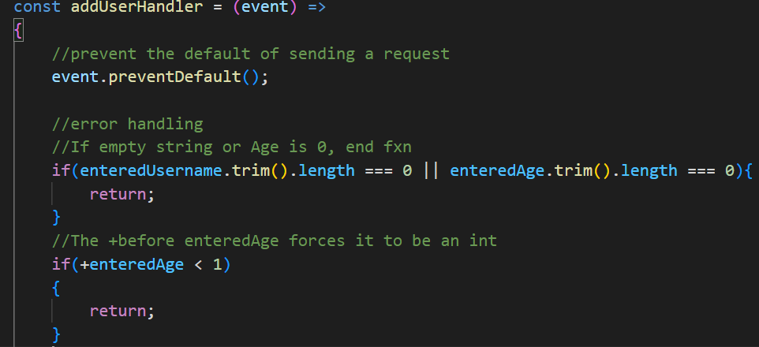

## 95. Adding a Users List component

We know that we could actually output the list underneath the form using an unordered list like <ul></ul>, however it is best to separate them out into their own components. So within the users folder we created a UsersList.js

**Planning out the UsersList.js**

When writing out the function we think about how we would want the props property to be delivered and decided it should be called users. Then once we grab that user array, we use map to distribute out the data. Map will apply the function to each item. So we decided we wanted each item to be a list item.

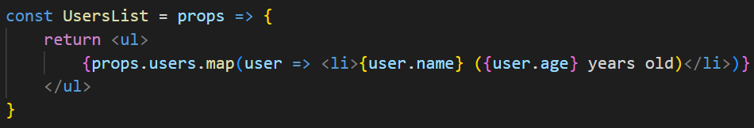

It’s up to us to decide how to manage our data. And we decided we want each object to have a name property and an age property.

Now that this is done, we go back to App.js and start a users prop. The name in the function eg ‘users’ must match props.users in UsersList

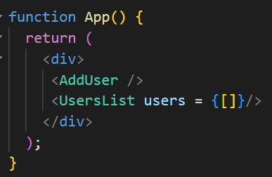

96. Manage a list of users via State

Need to “lift the state up”. The nearest component that has access to both add user and user’s list is App.js which is why we want to use it.

Within app.js we make up an onAddUser call where we pass our function. For educational purposes within these notes I called it randoHandler here as it could be anything, but it is actually called addUserHandler. (There is an addUserHandler fxn within AddUser.js also but they don’t have to be named the same, hence the name change for illustrative purposes). The onAddUser part will be called within AddUser.js via props.onAddUser

**Code shown on next page**

**App.js**

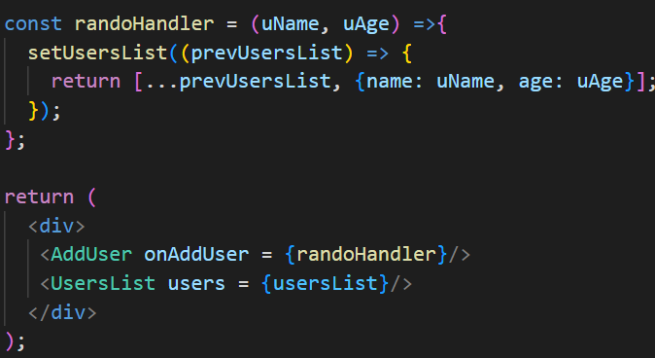

**Within the AddUser.js file, inside the addUserHandler function (**Note this fxn is called upon button submit and is a different function than the App.js handler). Here we send the data upwards.



Here is the ending image

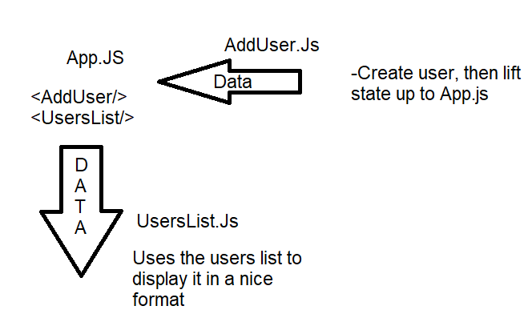

## 97. Adding the error modal component

We created an ErrorModal.js and put that into our UI folder as it is reusable. We also made a .css file for that as well. Then we added another div inside that referred to the .backdrop class. This allows the modal to cover up the rest of the page and made that non-interactable so the user must look at the modal and confirm the error. We could’ve either put the Modal in the app.js or the addUser.js, and we decided addUser was better.

## 98.Managing the Error State

We created an object that had properties with the correct error messages

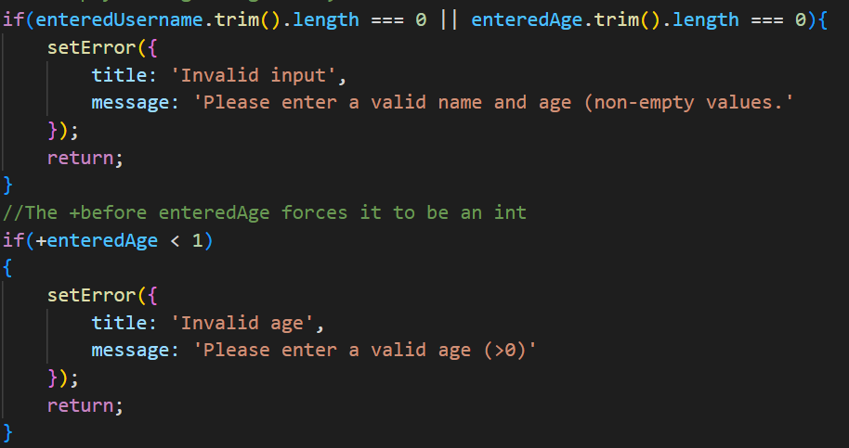

We then put in the JSX the condition that would make it show. If error was undef it wouldn’t show.

Once it was working we needed to clear the error state otherwise it would just be stuck with the modal

Within **ErrorModal.js** we added a onClick (standard for all divs) and then a props.onConfirm. (You can name the onConfirm anything you like)

The backdrop also has an onClick function so if you click the backdrop the modal goes away, if you remove that then you can only use the button, which can be good

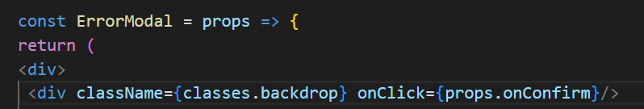



Our custom Button also has an onClick function since we designated that in the Button.js

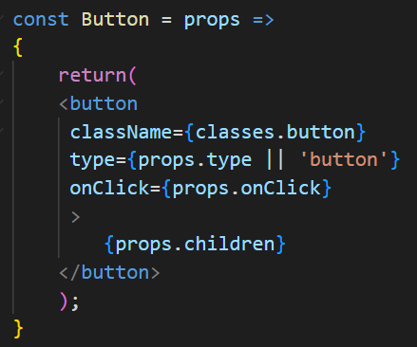

# Section 9: Fragments, Portals & Refs

Recall JSX is the code ran in React components, which in the end will be rendered to the real DOM by React. We use it all the time.

JSX Limitations:

1. **Remember we couldn’t have adjacent JSX elements side by side like**

<ErrorModal>

<Card>

**We could only have one root JSX element, which we normally got by, by using a div**

<div>

<ErrorModal>

<Card>

</div>

**Reason: React.createElement can only return one thing.**

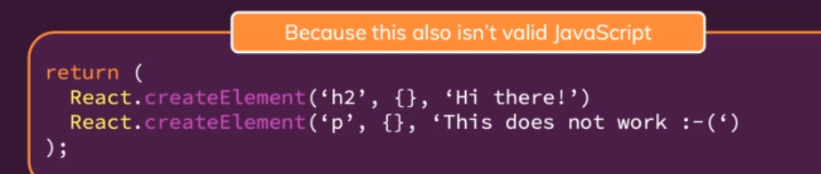

**Solutions:**

1.Workaround: Wrapping adjacent elements with a <div>

Much like wrapping three numbers and putting them in an array. It doesn’t have to be a div, it could even be a custom component

1. Native JS array

Return([

first obj,

second obj

])

Catch: warning because whenever you’re working with array of JSX elements, React wants a key for the array.

Course, we could hardcode the keys, but it’s cumbersome

**Wrapping <div> is way better**

**Cons: <div> Soup. So many <div>s being rendered in the DOM**

<div>s can break stylings and also makes browser slower since you’re rendering unnecessary content

**Solution: See next section**

## 102. Creating a wrapper content

What if we were to use a dirty little trick?

Within components we created a new folder called **Helpers**, then we created a file called **Wrapper.js**

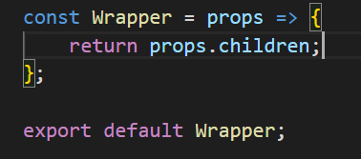

It only returns props.children

We went into AddUser.js and replaced the first div and it renders nothing, changed nothing and runs fine

## 103. React Fragments

Actually this wrapper is so common it comes with React. There are two ways. **First one always works**

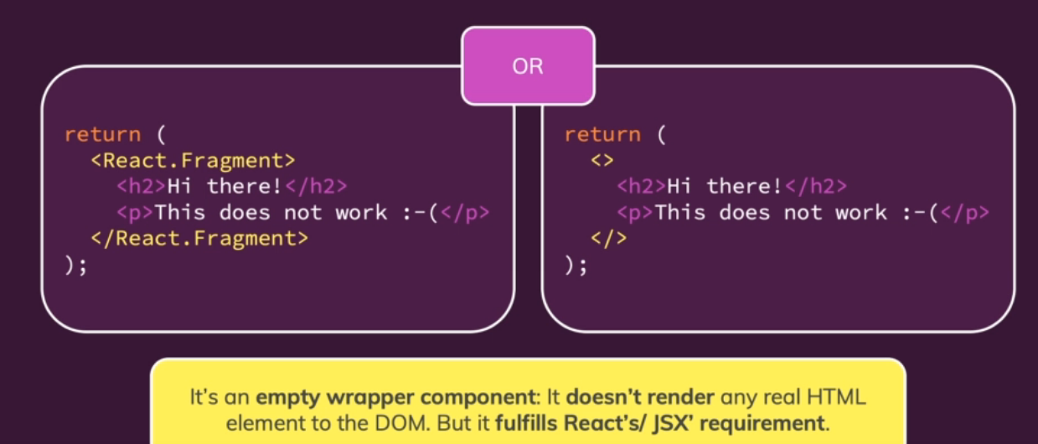

## 104. Understanding React Portals

Do something similar as fragments by helping write cleaner code

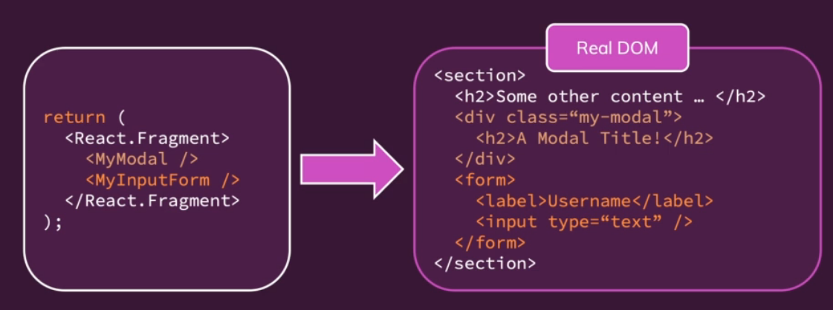

The modal code on the right is technically right and will look like modal but from a clean html perspective it isn’t ideal, it should be an overlay to the entire page.

It would be like making a div a button

<div onClick={clickHandler}> I’m a bad button </div>

A **portal** would keep the structure on the left but still render the real dom differently. Here the modal is on top of everything instead of next to the <form> and within the <section>

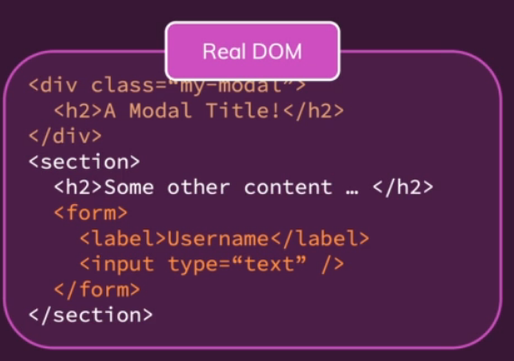

## 105.Working with Portals

Portals need 2 things, a place you want to port the component to, and then to let the component know it should have a portal to that place.

To mark that place, go to the public folder in the project and then to index.html. Here we added two divs with “backdrop-root” and “overlay-root”

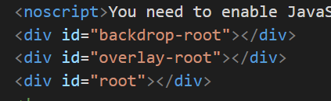

Within ErrorModal we snipped the backdrop and made it into its own const

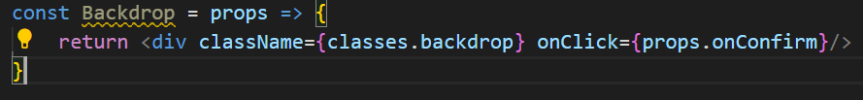

We also snipped The card and made that into its own const

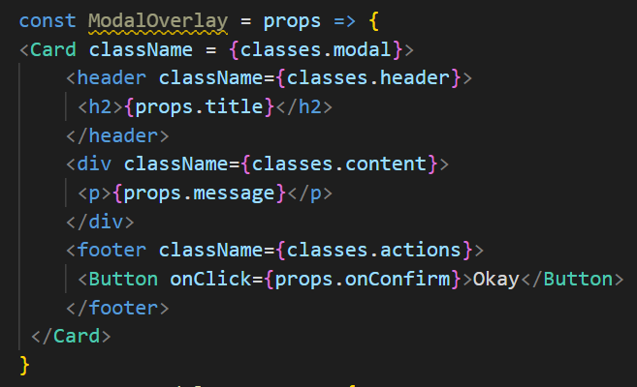

Leaving the ErrorModal const looking like this instead

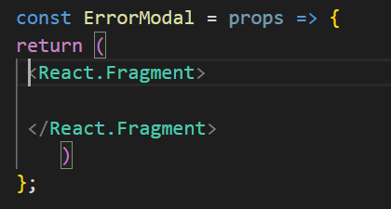

We imported



And on that we can call a method, **ReactDOM.createPortal()**

It takes two arguments, the first the react node that should be rendered, and then the next argument is a point to that container in the real DOM where this element should be rendered in. If we recall in index.html we want to render in that backdrop-root element component

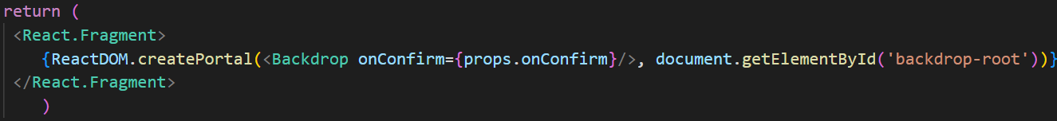

Now once you save it, it’ll always be there. No matter where you use your Error modal or how deeply nested it will be.

Now when we load the page we can see the backdrop is on top and no longer nested in the html code

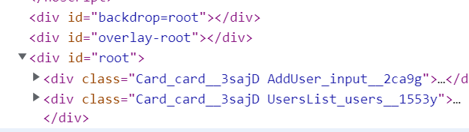

We then did the same to the modal.

Nothing changed while using the portal, we use it just the same as before.

You can use portals anywhere you use JSX code as long as you use {} braces

## 106. Working with Refs (References)

Allows to use with other dom elements and work with them.

Remember when we used AddUser.js and we updated the state with every keystoke so we could save it. Now we can use refs to setup a connection between an HTML element and our other JS code.

Within our AddUser.js file we added two new consts in our AddUser fxn

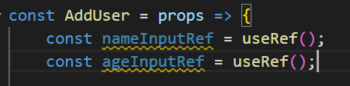

Then we added a ref which is a built-in prop that’s available for any html element.

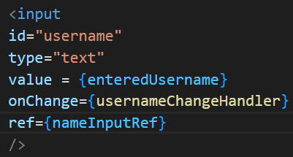

First time React renders the return, it will take the ref and put into the real dom

If you run the addUser handler, you’ll see that the nameInput ref will always have a current prop and it’s the actual DOM node, and you can actually manipulate it. **NOT RECOMMENDED. Manipulate using React. Read is ok**

Now we don’t need state, we can just read when the submit button is pressed.

Once we can use the refs we no longer need to listen to events and use the state so we removed the state for Username and Age and the constants.

**We’ve lost our resetting functionality, so**

We can reset our value by manipulating the refs, which normally we shouldn’t do but we can do here.

RARELY use refs to manipulate the DOM. We’re just changing what the user entered here. You can also go back to the state-based solution

If you only want to read a value, and you don’t want to change something, then probably better to use refs.

**This is just an intro to refs for now**

## 107. Controlled vs Uncontrolled components

Accessing values with a ref would be uncontrolled components. It is not **uncontrolled** because it’s not worked on with React.

Usually it would be **controlled**, like with the state approach. Their internal state is controlled by React

# Section 10: Effects, Reducers & Context

With these features we’ll be able to make more complex React apps

## 110. What are “Side Effects” & introducing useEffect

The main job of React was to bring something onto the screen and that the user may interact with something, and it may change based on certain events.

Side effects are everything else happening with the application. What else could be happening?

We could be storing data in the browser storage, sending Http requests to backend servers, setting and managing timers.

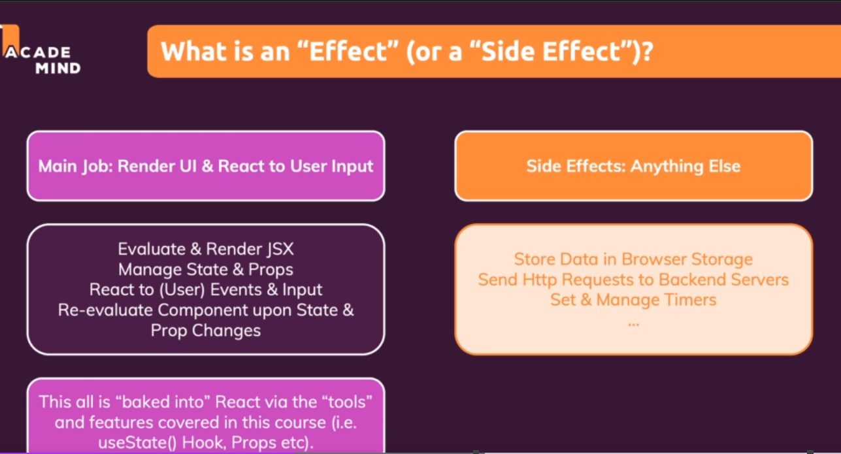

These tasks must happen outside the rendering because otherwise it might take too long to load the page

Side effects shouldn’t go into certain functions because sometimes it’ll send too many request or there will be bugs, etc.

**Introducing the useEffect() Hook**

useEffect is another built in hook you can run inside your component fxn that can do something

It is called with two parameters, first is a fxn that should be executed AFTER every component evaluation IF the specified dependencies changed. And the second one is the dependences to monitor

useEffect(() => {…}, [ dependencies]);

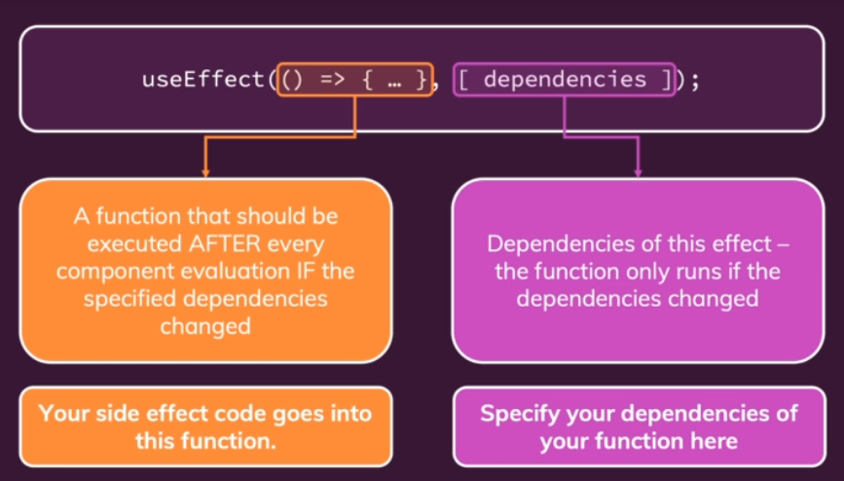

## 111. use the useEffect hook

We started a new project which I called **React-Hook-Router-Reduc-project**

Currently this login page, once you refresh, you’re logged out again. So you want the authentication status to be saved still. Currently it’s just logged in as some React state and so reloading, the entire script restarts and all variables are lost. (Nothing React specific)

Where can we store it so it persists after reload?

-After the app does restart, we check if the data is persisted. Then we log the user in automatically so the user doesn’t have to log in again.

**This would be a great area to use the useEffect hook.**

Cookies or local storage. Local storage is particularly easy to use so we will do that

We added 

We went to the page then to dev tools and then Application -> Local storage -> localhost and we could see the value we set there. This is how we can store data.

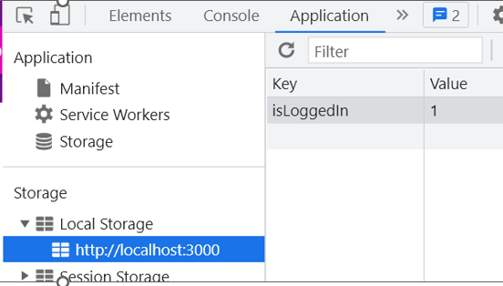

We can store something in the loginHandler as it only executes when the user logs in which is rare enough and when we want to store something. Don’t necessarily need useEffect here

**What about reloading the page?** Then we’d like to check for the key value pair

When the App restarts, the App() component function runs away.

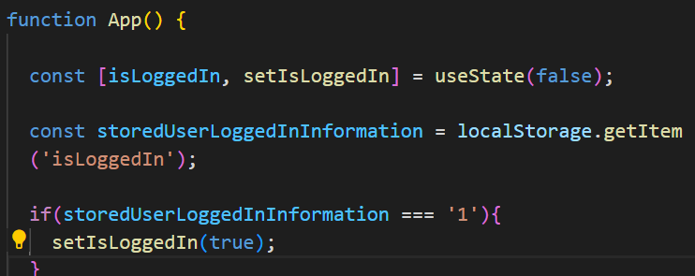

This would run in an infinite loop if we didn’t use useEffect as App would run all the time

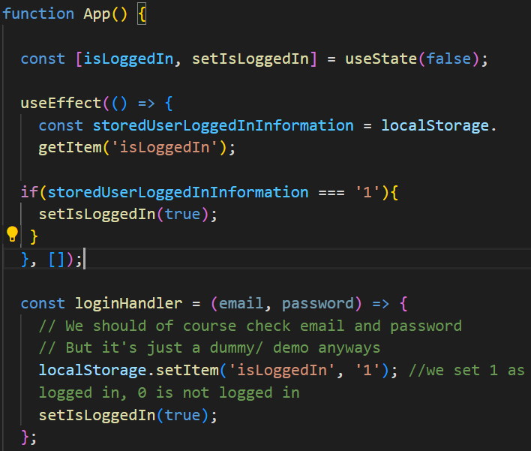

This would run at the start of the app because it recognizes that the dependencies have changed(since at the start you had none), but once it ran for the first time, they didn’t change, since the dependencies is an empty array

**Now when we reload the page, we stay logged in the logged in state because we have the key value stored.**

When we log out, we remove the item

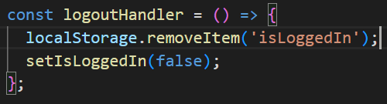

## 112.useEffect & Dependencies

Often, you need dependencies because you don’t want to run things just once. We looked at Login.js where the form is being rendered. There’s validation built in.

We could use useEffect in the validation, one logic if either the email or password changed.

Here we set the dependencies in the part as the function and the variables just like so.

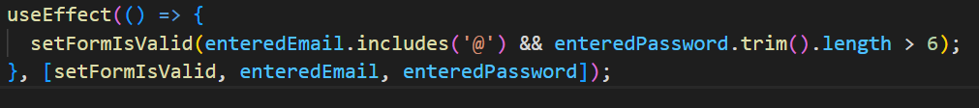

You can remove setFormIsValid, since it’s a React component and those will never change

UseEffect is good for when a component is rendered for the first time, or when certain data/props changed

**What about updating the react state?**

UseEffect is used to handle side effects, and often its used for http request and storage etc, but it’s also used to check for side effects of user entering data. So for example, checking and updating the form is a valid action of useEffect

## 113. What to add and what not to add as dependencies

We learned that we should add everything used in the function as a dependency, i.e. all state variables and functions you use in there.

**However**

* You don’t need to add state updating functions that React handles ( like setAge) React ensures these will never change
* “built-in” APIs or functions like fetch() localStorage (things that are available globally). These also never change
* Also don’t add any variables or fxns that you defined **OUTSIDE** of your components

## 114. Using the useEffectCleanup Function

Our form checking validity is great when it checks every key stroke, but not if it was for something like HTTP request.

Instead we could just collect a certain amount of keystrokes, or wait for a longer pause. We only care when the user stops typing, then we can check it after 500ms or so

This is called **Debouncing -** a programming practice used to ensure that time-consuming tasks do not fire so often, that it stalls the performance of the web page. In other words, it limits the rate at which a function gets invoked

We set a timer

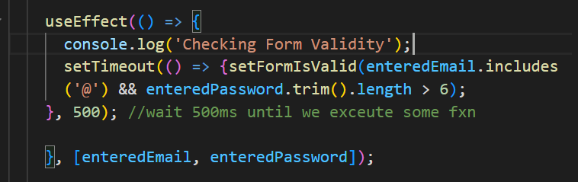

The trick is to reset the timer so that if the user starts typing again the timer resets so that we only have one timer at a time

**useEffect** makes this pretty easy.

We add a return to our useEffect function, which runs:

* Whenever the useEffect runs
* Before it runs, except for the very first time it runs
* Whenever the component unmounts from the DOM (whenever its reused)

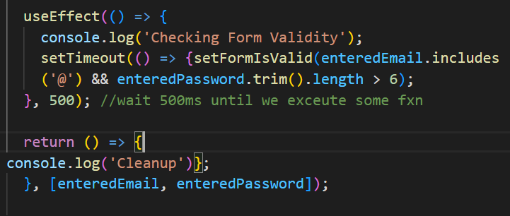

We tested it in our browser with console log

1. Not before the first time (component loading)
2. After we typed our first character it ran once, before the side effect (validity console log)

We added a new timeout constant to clear the timer so that it would only check validity when someone stopped typing.

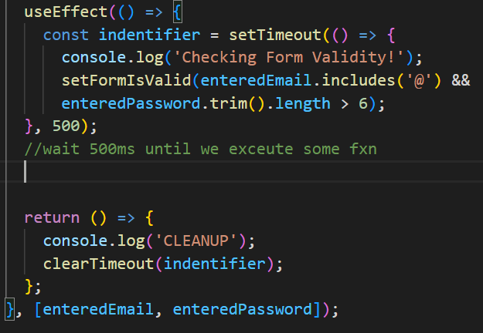

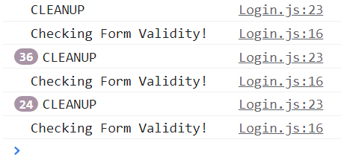

## 115. UseEffect Summary

Very important part of React, so we wanted to go over a few important things again

1. This would run at the start and for every key stroke and render after that

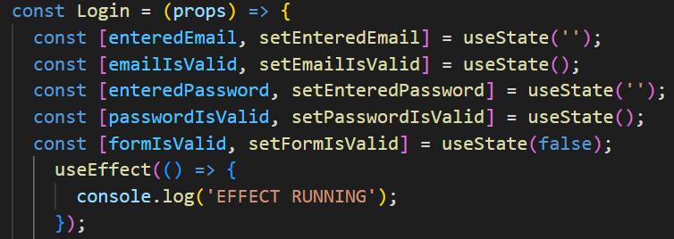

1. If we added an empty array, the fxn would only execute the first time the component is mounted and rendered and not anything other time (Only run once)

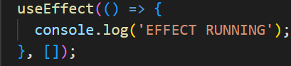

1. What about with a dependency?

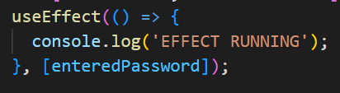  
Now this fxn whenever the component is re-evaluated, and when the dependency changes

1. The cleanup function, which can return

Cleanup runs before the state function runs, but not before the first time it runs.

If you have cleanup with an empty array, then we see effect running once, and then cleanup runs once when the component is removed (eg user logged in)

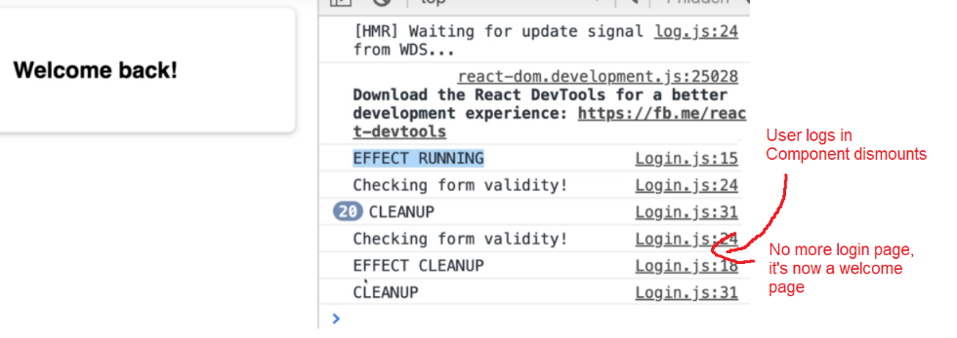s

## 116. Introducing useReducer and Reducers in general

Another built in hook, that will help us with state management, like useState but will have more complex state. It could:

* Have multiple states
* Multiple ways of changing it
* Dependencies to other states (they change together or are related)

useState then is not ideal since it becomes **hard to use** or **error prone**.

**useReducer()** can be used as a **replacement** for useState() if you need **“more powerful state management”**

You shouldn’t always use useReducer because it’s more powerful, since it’s more complex to use and set up

**Majority of the time you’d probably use useState**

**What’s a good example?**

Login.js, where we manage the enteredEmail, entered Password but also checking if they are valid and if the form is valid. So we could see that as one big state, that tracks the overall form state. Or you can at least treat every input as one state, which has two aspects: value and validity.

**There can be some redundancy here so we might want to manage them together**

If you update a state which depends on another state, you could useReducer here.

## 117. Using the useReducer() hook

useReducer, just like useState, always returns an array with two values.

First one is state snapshot, but now you also get a fxn that can be used to dispatch a new action. Kind of like setState in useState, but instead of setting a new state value, you’ll dispatch an action. That action will be consumed by the first arg you pass to useReducer on the right, a so called useReducer fxn. It gets the latest state snapshot automatically, and it gets the action it was dispatched.

React will call this reducer fxn whenever a new action is dispatched. Then the reducer fxn should return one important thing: The **new updated state.** It’s a bit like the fxn form of the useState hook but an extended version. You can also set some initial state and initial fxn (in case initial state is a bit more complex. We’ll ignore that for now)

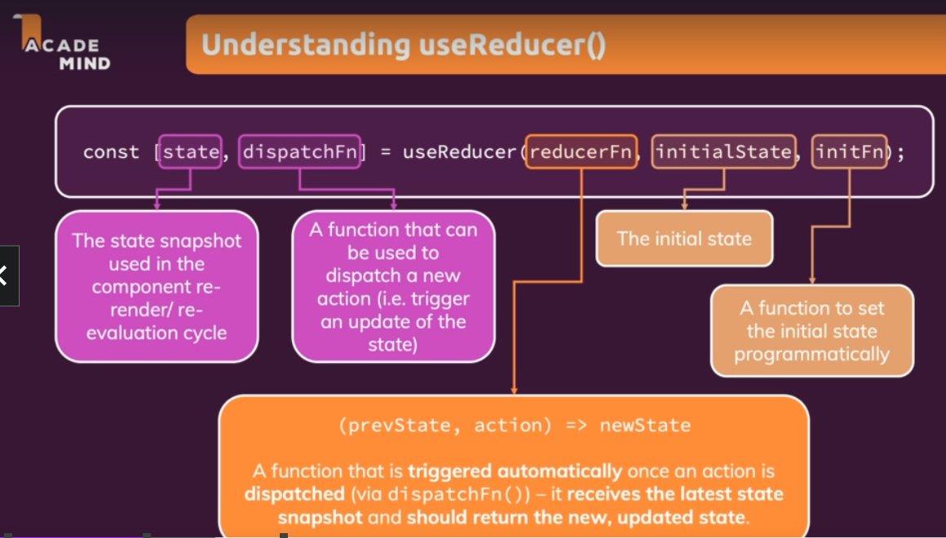

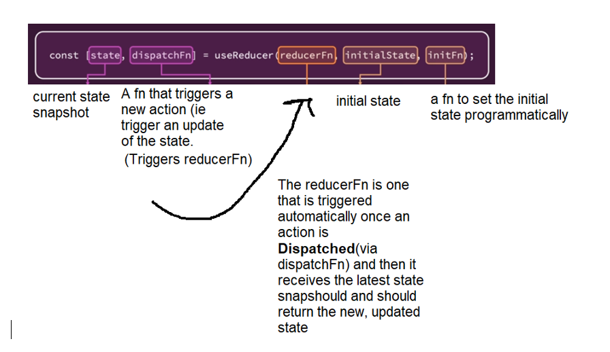

**Here we begin our demo of useReducer**

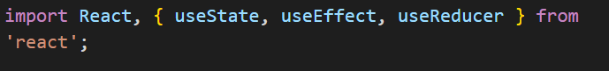

We wrote our useReducer and then the reducerFn separate since we don’t need any of the data generated from the reducerFn. The reducer function returns the new, updated state



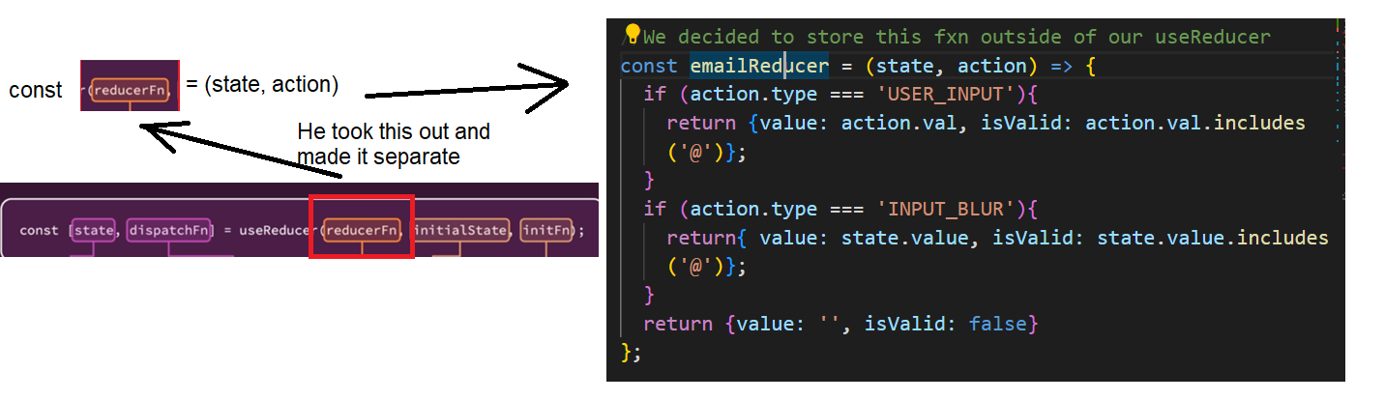



In doing so we also learn that the reducerFn gets all the data it needs by React automatically. It receives two parameters, our last state snapshot, and the action(see number 4 on the right)

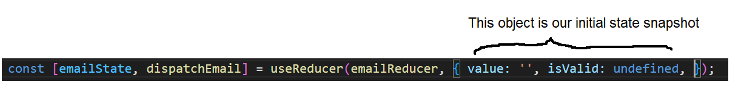

Instead of enteredEmail, we can now use emailState.value as it has the current state snapshot. So we replaced enteredEmail with that in all our code. Now reducerFn should receive the latest state snapshot, and then should return the new, updated state.

Within the emailChangeHandler, we call the dispatchEmail fn which is the dispatchFn, we pass to it an action, which is up to us what it is. Often it’s an object which has some field and identifier, and an extra payload to this action. Here our payload is event.target.value which we named val

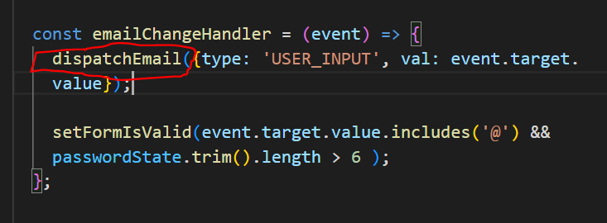

This calls our reducerFn, emailReducer. And then we return another object with the value being our payload and we also check for validity

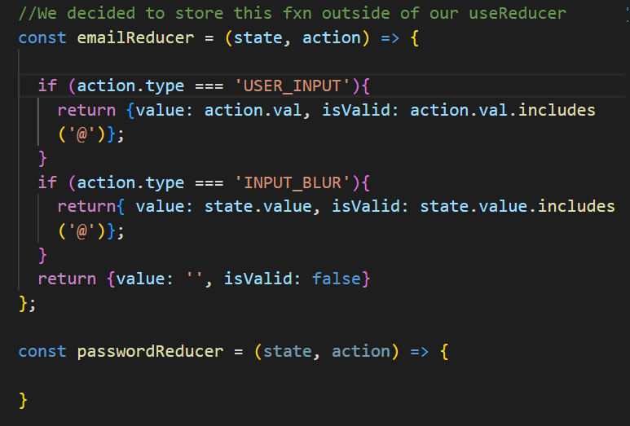

Input blur is when you lose focus on that element (eg clicking away)

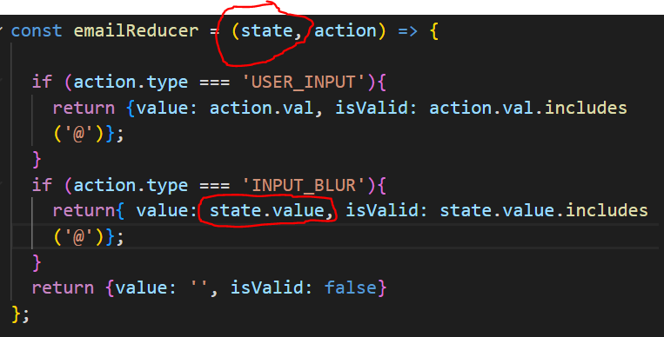

If user clicked away we still want to check the value in case it’s valid, so we check the state.value. The state is guaranteed by React to be the last state snapshot.

**We do the same thing for password but change a few things**

**We don’t want to rely on state.value for form validity however, since React schedules these updates and we might get an older one.**

We commented out our form validity and went back to our commented out useEffect and changed the values to use. useEffect runs after state updates so this is an ok way to do it

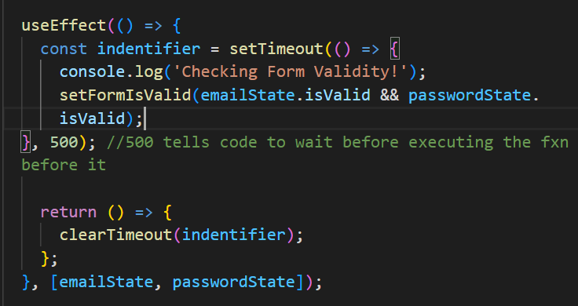

**However!**

This effect runs too often, it runs everytime emailState and passwordState changed (values change)

For example, if the password was 6 characters, but then it was 7 characters, form validity will check again

We are only interested in the validity part

**We use object destructuring**

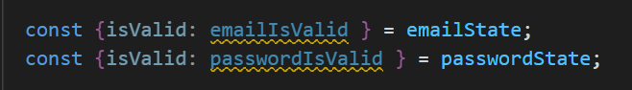

Here the object is on the left side which is destructuring, and we assign an ALIAS to the property

So for emailState the property isValid is now called emailIsValid and passwordState has one called passwordIsValid

We then changed our useEffect to take in those new aliases

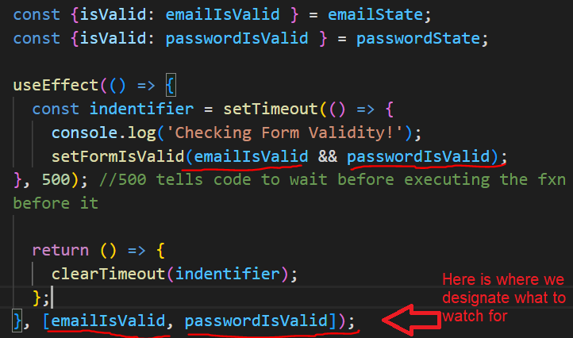

**Ex. For object restructuring, you can use that for props too, so you don’t run your effects every time props changes**

## 120. useReducer vs useState for State Management

In general, useState will become cumbersome or getting a lot of bugs/unintended behaviors

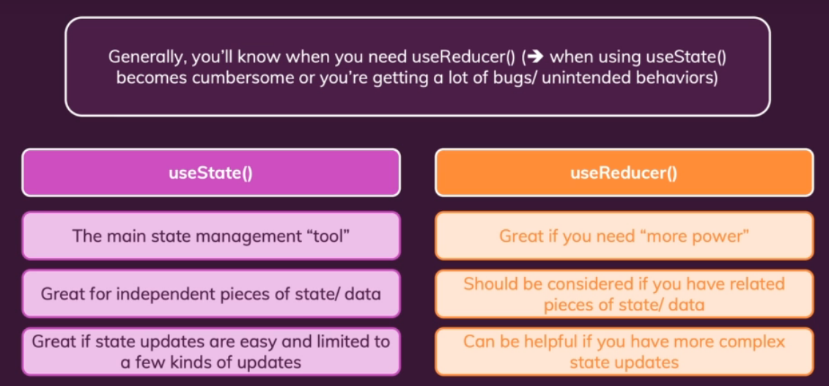

Generally if you have something that’s switching between only two states, no need to useReducer as that’ll be overkill

121. Introducing React Context (Context API)

An issue that came up even with our simple app is the fact that we’re using props a lot. The login state everywhere as well as the log in functions. This state was lifted up because we need it everywhere.

Passing our state around a huge app is a huge problem. The chain of passing props around of a fictional larger app will only get longer and longer.

After a while the products won’t even need that props, it’ll just need to forward data.

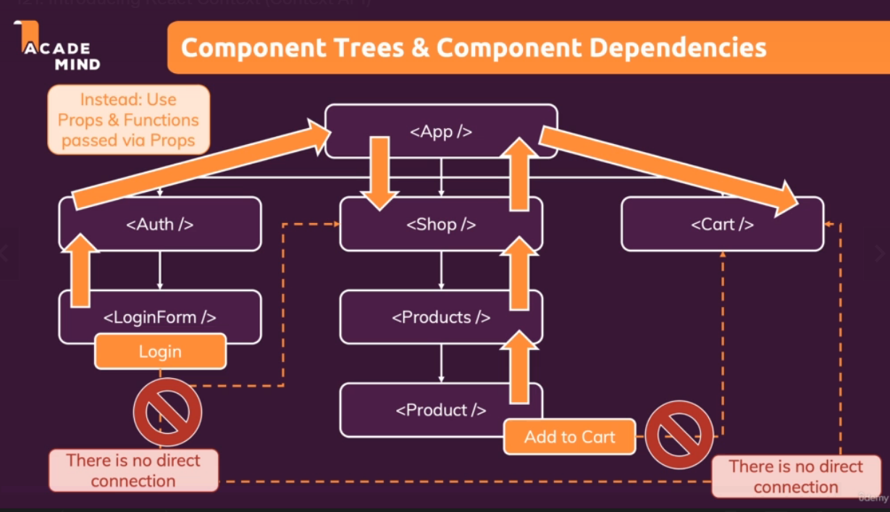

React Context to the rescue! Introducing State Storage, where it triggers an action to state storage and pass that info directly to the component that needs it.

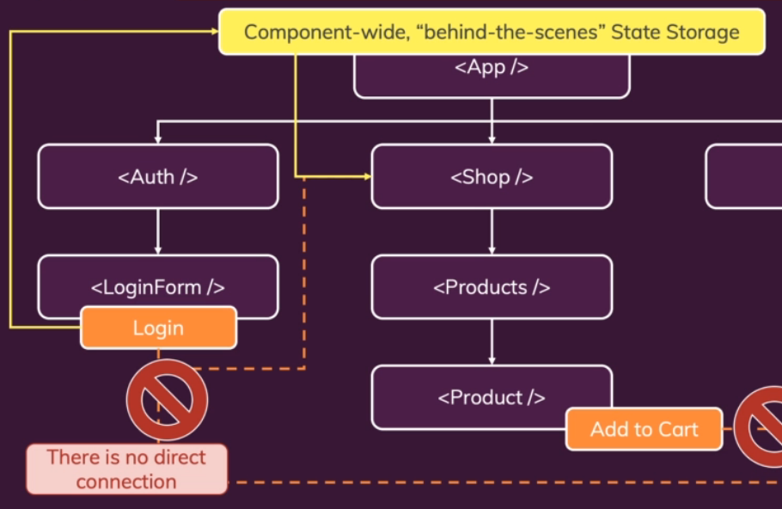

## 122. Using the React Context API

We no longer need to build a prop chain

We created in the src folder a folder called **store ->** then added a file auth-context.js

Your context could be anything you like, it could even be text like,

React.createContext(‘my state!’);

But often it’ll be an object. Here it’s an isLoggedin state which we set to false initially

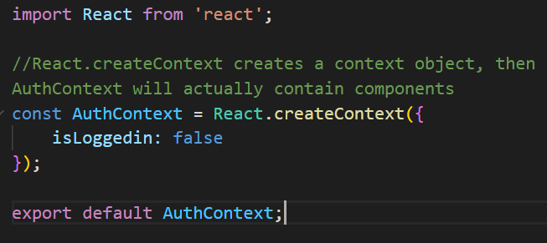

What we’ll get back is an object containing a component.

We don’t need the component here so we’ll export it to use in the other components.

To use context in your app you need to do 2 things

1.Provide it – Tells React, Here’s my context, all components that are wrapped by it should have access to it (More info on that later).

2.Consume it – Hook into /listen to it. (Components that are not wrapped will not be able to listen to it)

**It really depends where you’ll know you need it.** Here we need it in app.js since we need it everywhere but if you know you need it in login only, you can wrap it around the login

AuthContext is not a component but when we use AuthContext.Provider then that is actually a component, which we can wrap around other components.

All their children and their children’s children will have access to it.

**Within App.js**

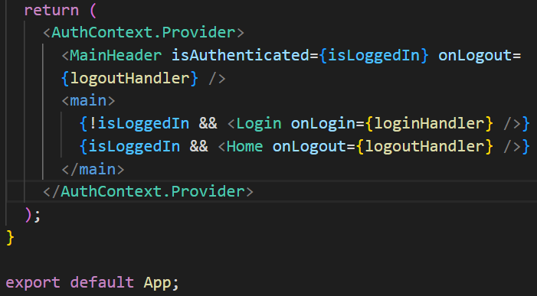

**Now for the listening part**

2 ways, React Hook and AuthContext.Listen. Usually we’ll use React

Within App.js we used AuthContext.Provider to wrap around our code, then 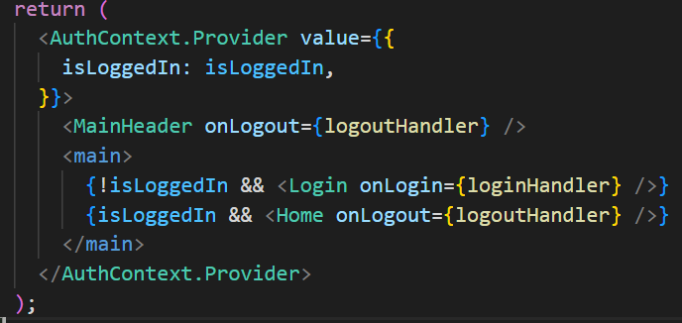

We used an arrow function and used that instead of props, thus we could delete all the references to props login via App.js -> MainHeader.js -> and Navigation.js

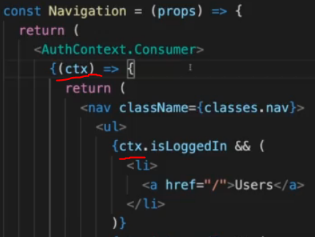

**We decided we didn’t want to use that arrow function and so removed AuthContext.Consumer and imported** 

Now we can just tap into the context and use it.



This method and the previous method are both valid, the second one just looks cleaner

## 124. Making Context Dynamic

We don’t want the logout function to have to be passed either, so we can declare it in App.js

We can pass data and also functions

Within the AuthContext.Provider

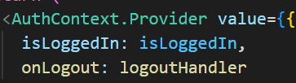

But what about this button within Home.js?



For this it’s better to use props as we don’t always want a button to log the user out

**In most cases you’ll use props to pass data to components**

Props are your way to configure components and to make them reusable. Only use react Context when you have to forward something through a lot of components and that component does something very specific, like navigation where it will always log someone out.

## 125. Building and Using a custom context provider component

It’s a good idea to put your functions into the auth-context.js (or wherever the default context is stored)

Here we just store a dummy function which does nothing so the IDE can reference these things better

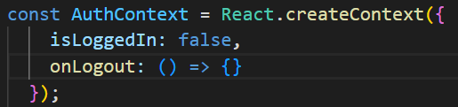

You might also want to pull out more logic from App.JS and create a separate Context management component.

**How could this look like? (Optional)**

We took out code from login.js and home.js to add into the auth-context.js component

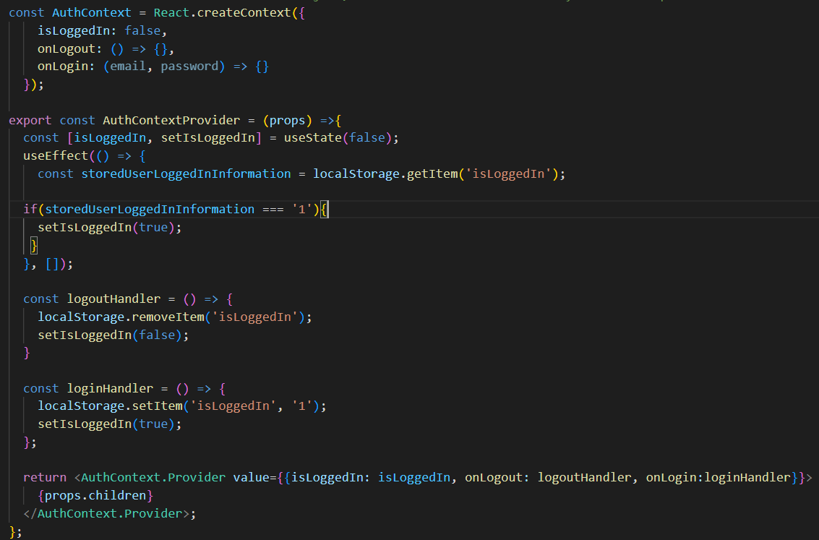

Then in index.js we wrap the entire app in the AuthContextProvider



**Devs are a fan of this split since it’s a practice you might see and might want to look into**

## 126. React Context Limitations

React context can’t be used for anything, it can be good for app-wide/component-wide states (states that affect multiple components) but it’s not a replacement for component configuration

Etc. using a button component to log someone out, but then you’ll want the button onClick to still be able to be used for other things.

-It is NOT optimized for high frequency changes. (State changes every second or multiple times per second)

Our login function would probably once every few minutes etc.

**What if I have app-wide or component wide states that changes often? I want to use React Context (Instead, try Redux, will be explained later)**

## 127. Learning the Rules of “Hooks”

useState, useEffect, useReducer, useContext (There’s even more hooks than that)

**RULES for working with react hooks**

Hooks are those functions that start with “use” like useState, useEffect, useReducer

1. Only call React hooks in **React functions**
   1. React Component Fxns (where they return JSX)
   2. Custom Hookers (covered later)
2. Only call React Hooks the TOP level

* Don’t call in nested or block statements (ex like within another hook, or in an if state)

**+ extra, unofficial rule for useEffect(): always add everything you refer to inside of useEffect() as a dependency!** (the state updating fxns used by useReducer are guaranteed to never change)

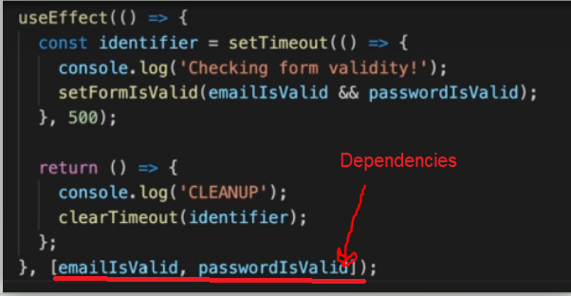

## 128. Refactoring input component

Made a new folder within the UI folder > Input > Input.js,

We extracted the input div from Login.js and put it into Input.js, and also the control parts of the Login css file so that we could add that into our new css file called Input.module.css

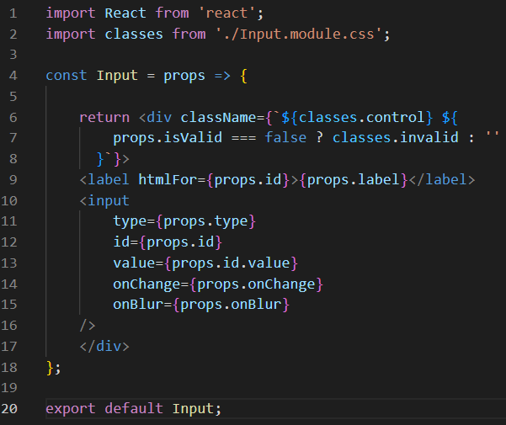

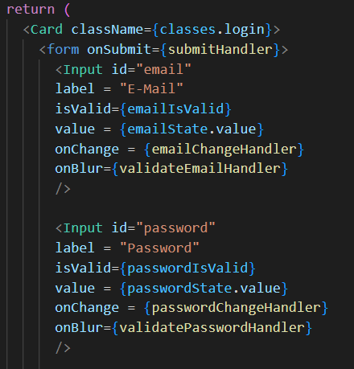

**This is a good example of when to not use context, as then we couldn’t put both email and password for the input component**

## 129. Diving into “Forward Refs”

For this next hook we want to pass data imperatively into the component and not via a state that changes something inside the component. We call a fxn inside the component. We don’t do it very often but it can be helpful.

From the **Login.js**  button we removed disabled={!formIsValid} because we want it to be enabled all the time for our future code

As just an example to demonstrate how to work with refs for the function we’ll be writing later, **Within input.js** we show that when you use refs into input html tags you can focus on them, a useful tip for later

Now within **Login.js** we add some refs for our input section (shown below)

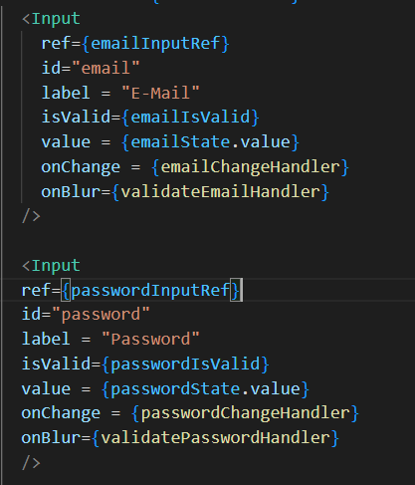

We also add to our submit handler a new focus fxn call

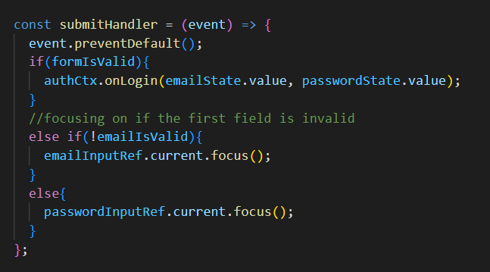

Normally, in React projects it’s best to work with props and state and pass data via that functionality

But for this part, within Input.js we have created a new activate fxn, which we want to call this **activate** function from outside

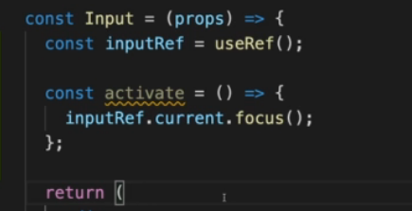

**This is a rare use case where we want to have an activate component on our custom input.js module**

To use refs like this but for React components, we have to import useImperativeHandle from react



Within **input.**js, we also had to wrap our input ref with React.ForwardRef

For our imperativeHandle fxn, the second parameter is a function that will return an object. The object contains all the data you’ll be able to use outside. The first field can be whatever you want to call it (You will then use this name outside the component (we will use it in Login.js when we call emailInputRef.current.focus). The second will be the name of the internal function/variable that will be accessible from the outside through that name. (Here it is the activate fxn)

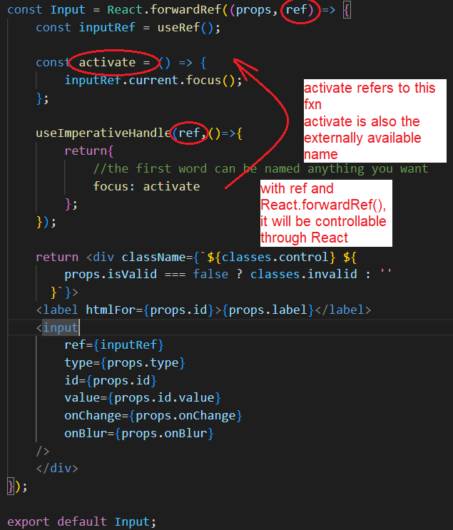

While this is a very niche case, sometimes you will want to do this for input components, so it’s a very realistic example to trigger certain functionalities

# Section 11: Practice Project: Building a Food Order App

-npm install to run all dependencies, then npm start to start the server

**Src**

>components

Within the **Components folder,** Here is what the Udemy Instructor wanted his app to be split into

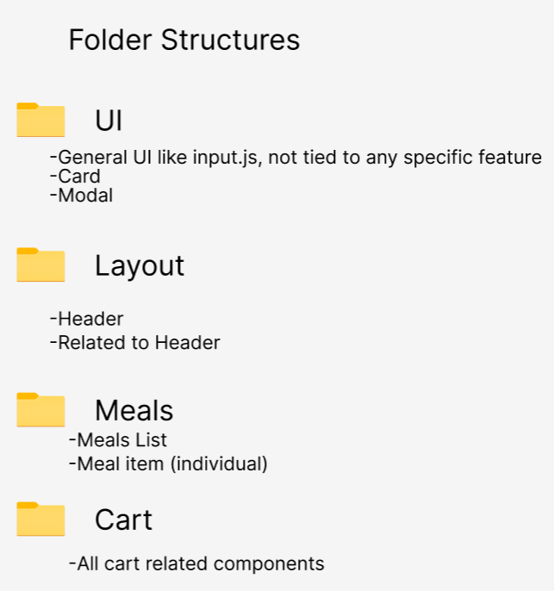

Added a **Header.js** into **Layout**, along with **Header.module.css** file, added some code, and then created another folder, assets

**Src**

>components

>assets – Here there will be some images

Now we add the header image

**Instead of the usual html like <img src=’’>, we import it!**

then under source we can use the alias that we named it

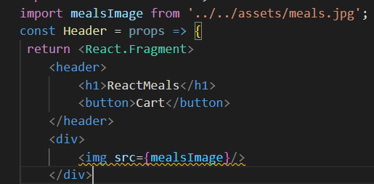

if the src was on a server somewhere you can just use the html link as usual

